Preface

This Guide is intended to be read by system administrators responsible for setting up and maintaining the parameters that govern how the system operates with regard to accounting.

# Accounting Principles

Accounting postings generated as a result of trade finance activities can be grouped broadly into the following areas:

|  |  |
| --- | --- |
| Advances and repayments | Postings used to pay funds to the credit party as a result of establishing loans and then later reducing the outstanding loan amount through repayment. Such postings are used only where the financing module is not implemented. |
| Charges | Postings to debit the appropriate party for the charge amount, with opposite entries to credit the charge income profit and loss account. |
| Collateral | Postings used to record value of collateral held in relation to a transaction |
| Disbursements | Postings used to pay funds to parties for transfer letters of credit, assignment of proceeds or back-to-back letters of credit. |
| Discounting | Postings used to pay funds to the beneficiary at a date earlier than the original settlement date, with discount interest being calculated and posted for the deal period involved. Such postings are used only where the financing module is not implemented. |
| Financing | Postings used to record a financing transaction. This is relevant only if you have the financing module implemented. |
| Financing Repayment | Postings used to record repayment of a financing transaction. This is relevant only if you have the financing module implemented. |
| Foreign exchange | Postings used to record the receipt of foreign currency purchased against the sale of the required currency (or vice versa). |
| Payments | Postings used to reduce liabilities and to debit the paying party and credit the beneficiary. |
| Recording of liabilities | Postings used to record details of liabilities arising from the issue of letters of credit, acceptance and creation of collections with opposite entries to internal contra accounts. |

The system allows postings to be defined in two places:

* When setting up charges, you can define how income from charge types is to be booked. The customer account to be debited is derived from the settlement instructions held for the charge payer
* All other postings are defined for the individual events associated with each product. You can define a number of postings for each event; the postings defined for an individual event are called a posting set

## Accounts

Accounts are identified by a ‘Back Office account number’ up to 34 alphanumeric characters long. The account must be unique and corresponds to a single account in the back office. Each account can also have an alternative external account number for the bank’s own purposes and an IBAN (International Bank Account Number).

The system generates postings to three types of account:

* Customer accounts, used for recording liability and for funds settlement
* Internal accounts, used for recording contra liability, profit and loss and as settlement suspense accounts
* Charge income accounts, which are also internal accounts, and which are used as profit and loss accounts to receive charge income

The following parameters are used to define the accounts to which postings are to be made:

|  |  |
| --- | --- |
| Parameter | What It Is Used For |
| Account types | These define the main characteristics of accounts (for both customer and internal), for example whether they are contingent or non-contingent |
| Charge codes | These are used with charge income accounts, and define the account's account type and transaction codes to be used for postings to that account |
| System parameters | These are used with internal accounts, and define the account's account type and transaction codes to be used for postings to that account |

### Customer Accounts

Customer accounts are identified using the following information:

* Branch mnemonic – The branch's mnemonic which also provides the branch number
* Customer mnemonic - The customer's mnemonic, which provides the customer basic number
* Account type - which is used to define the account characteristics
* The currency of the account

Example:

Branch - LOND

Customer - ABC LTD

**Account type –** RA – LC issued (contingent)

Currency - USD

is associated with:

Back Office account number -LOND-12345696-USD-600

**IBAN –** GB29 MISY1200 1212 3456 96

### Internal Accounts

Internal accounts are generally identified using the following information:

* Branch mnemonic – The branch's mnemonic which also provides the branch number
* System parameter - which determines the general ledger category code and account type to be assigned to the account and the transaction codes to be used for postings to the account
* The currency of the account

Example:

Branch - LOND

System parameter – SP501

Account type – TA – LC issuance liability contra (contingent)

Currency - USD

is associated with:

Back Office account number -LOND-89700000-USD-840

The system also maintains exchange position accounts by currency pair so some accounts related to SP101 Exchange Position system parameter will additionally be identified by.

* **Other currency** – used for the other currency when foreign exchange trading positions are held by currency pair

Example:

Branch - LOND

System parameter – SP101

Account type – YX – Exchange Position Actual

Currency - USD

Other Currency - GBP

is associated with:

Back Office account number -LOND-88184000-USD-826

### Charge Income Accounts

Charge income accounts are identified using the following information:

* Branch mnemonic – The branch's mnemonic which also provides the branch number
* Charge code - which determines the general ledger category code and account type to be assigned to the account and the transaction codes to be used for postings to the account
* The currency of the account

Example:

Branch - LOND

System parameter – DF – Deal Fee

Account type – YP –Profit & Loss

Currency - USD

is associated with:

Back Office account number -LOND-90080000-USD-840

### Back Office Accounts in Event Fields

The system option BOSubA/cDefn, described in the System Tailoring User Guide - Trade Innovation, determines what part of the back office account number is inserted in an event field, for use in documents or clauses. This does not affect the use of the back office account number in postings.

### Settlement Postings

Where a posting represents a movement of funds, you can use data from the event itself to identify the amount, party, and the associated settlement instructions type to be used. You may identify the settlement instructions type to be used as either:

* Principal
* Interest

When a posting is generated for a funds transfer being made to a party, the system retrieves the appropriate settlement instructions for the principal, interest or charge amount being paid/received. These determine the account or nostro through which funds are to be settled and the settlement instructions to be applied.

In general, the settlement instructions are obtained in the following sequence:

* Master level instructions from the main event
* Master level instructions from the subsidiary event
* Customer standing settlement instructions using the main event instruction group
* Default nostros
* Suspense accounts

The system searches for settlement instructions in the following way:

* It first looks for settlement instructions defined for the master against which the posting has been defined, to identify settlement instructions for the funds movement.
* It will then search for either the branch-level customer standing settlement instructions, or bank-level settlement instructions, depending on your system options*. The system uses the Behalf Of Branch for retrieving settlement instructions.
* If no instructions are found for the master, the system then checks for customer standing settlement instructions (at bank or branch level) for the appropriate settlement type (principal, interest or charge) for the relevant settlement instruction group, as defined for the product. If no instructions are found for interest or charge types, then the system searches for principal instructions for the instruction group.
* If the system cannot find instructions at instruction-group level, then it retrieves instead the general instructions defined, which are not specific to any particular instruction group.
* If no settlement instructions are found at this level, then the system uses the default nostro for the branch and currency.
* If settlement instructions are found, and they specify a settlement currency but do not specify a settlement account or nostro, the system uses the default nostro for the settlement currency.
* If no default nostro exists, then the system uses the SP500 Trade Finance Settlement Suspense account instead.
* If any error occurs during settlement, then the system will use the SP148 Error Settlement Suspense account. The reason for the error will be written in the narrative details on the settlement instructions, so that the cause can be identified and corrected.
* Your bank can set a system option so that the system will not use separate charge instructions at payment. In this case, in a payment event, charges will always be netted with the principal amount being paid or received, rather than creating separate charge settlements.

1. Branch-level and customer-level settlement instructions are mutually exclusive. See the Static Data Maintenance User Guide – Trade Innovation for more details.

### The Timing of Postings

When postings are generated for an event, the full details of all the postings that apply to the event can be reviewed from the postings window. When the event is released, postings that are due are then passed to the back office system. The system initially only passes those postings to the back office system where the value date have been reached. Where forward-dated postings represent a funds movement, they are passed to the back office system as projections so that they can be included in cash and nostro ladder enquiries and in future maturities reporting. Other future-dated postings related to non-funds movement are not projected.

When the value date of these projected postings is reached, the batch process identifies any funds movements which are due, and passes a posting to the back office which can be used to change the funds movement from a projection to an actual posting. At the same time other future dated postings to non-funds movements accounts are also posted, such as postings to charge profit and loss accounts.

In the following example, a payment is entered on the 27th July 2012 for settlement of 50,000.00 USD to be made to the drawer on the 29th July 2012 against a previously accepted draft. Charges of 30.00 USD are to be deducted from the proceeds.

The following postings are made:

|  |  |  |  |  |  |
| --- | --- | --- | --- | --- | --- |
|  | DR/CR | Account | Amount | Currency | Date |
| 1. | CR | Customer avalised liability | 50,000.00 | USD | 27JUL2012 |
| 2. | DR | SP509 | 50,000.00 | USD | 27JUL2012 |
| 3. | CR | Drawer | 49,970.00 | USD | 29JUL2012 |
| 4. | DR | Collecting bank | 50,000.00 | USD | 29JUL2012 |
| 5. | CR | SW - SWIFT | 30.00 | USD | 29JUL2012 |

This will result in an immediate change in liability (entries 1 and 2) value-dated to the 27th July 2012, with projections for the 29th July 2012 being made (entries 3 and 4) for funds movement reporting.

During the batch process on the 29th July 2012, the previously projected amounts in entries 3 and 4 will be posted together with entry 5 which is now also due.

### The Netting of Postings

The system nets settlement postings for the same event together where possible.

In the following example of how the system generates settlement postings for an event, a payment is being made in USD to a beneficiary wanting to be paid in GBP.

The system generates the original posting to the customer as:

* We Pay Beneficiary 1,620.00 USD Via Account 1200-123456-001

Then the exchange postings associated with the foreign exchange deal are generated as:

* We Rec Beneficiary 1,620.00 USD Via Account 1200-123456-001
* We Pay Beneficiary 1,000.00 GBP Via Account 1200-123456-002

This results in accounting entries 1 and 2 netting together to zero, as they settle via the same account. There remains a net pay in GBP.

However, the system needs to cater for the fact that the beneficiary may have separate Pay and Receive instructions (such as Pay USD via Chase with Receive via Account 1200-123456-001); otherwise this example could result in two Pay settlements and one Receive, as follows:

* We Pay Beneficiary 1,620.00 USD Via Nostro CHASE.
* We Rec Beneficiary 1,620.00 USD Via Account 1200-123456-001.
* We Pay Beneficiary 1,000.00 GBP Via Account 1200-123456-002.

To cater for this, the system nets postings in a particular sequence so that exchange and finance postings can join with previously generated postings which match by:

* Party
* Amount
* Opposite Dr/Cr direction
* Value date

The system achieves this by:

* First generating all the postings for the event and any associated and subsidiary event
* Secondly, attempting to net together any remaining postings that are in the same Dr/Cr direction and are for the same party, amount, account, and value date. The system starts with the postings generated for the main event
* Thirdly, attempting to join in postings for subsidiary events (such as participation and financing postings), charge postings, foreign exchange postings, or money market postings that match existing postings. As part of this process, the system alters the settlement instructions of the original posting. Where a posting does not join in with an existing posting, the subsidiary event retains its original settlement instructions

## Liability in Trade Innovation

You can use postings definitions to control the figures that are displayed as liability on the master Summary window for each transaction. These figures are controlled by two fields that are displayed when you are setting up a posting - the Liability field and the Track Residual Liability field, illustrated below:

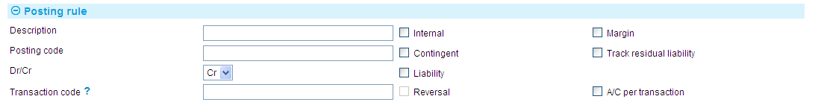

The figures on the Master Summary window reflect only those postings that have either or both of these flags checked.

The Liability field is to be checked only if the posting is to a customer liability account. This field is also used by the system to determine how much needs to be drawn down or revolved on a participation deal relating to the transaction. The system takes the net value of all postings for which the Liability field is checked. A debit balance results in a drawdown, and a credit balance results in a revolution (if the participation deal is revolving).

The Track Residual Liability field can be checked when the posting is to a customer liability account and when defining a posting involving accounts for banks sharing liability. While this field is available for use on all products, it is only really necessary for products such as letters of credit, where the transaction risk can move from one category to another during the life of the transaction.

For example when a usance letter of credit is issued, the risk will be booked under an LC Usance Issuance risk category. When a claim is received for payment by means of acceptance then part of the risk (the amount claimed) will move from the LC Usance Issuance risk category to the Acceptance risk category. The system maintains the two liability figures on the master Summary so that the user can distinguish the overall risk from the issuance risk. This separation also ensures that when a letter of credit is expired the system can accurately create postings to clear out any residual issuance liability (that is, the amount that has not been claimed).

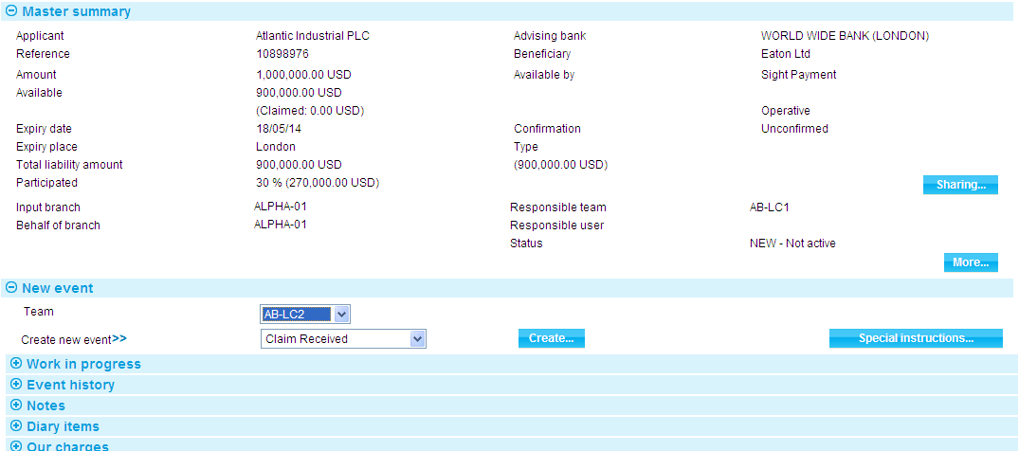

Chapter 3 contains examples of usage of the Liability and Track Residual Liability fields when sharing customer and bank liability.

## Shared Liability

This section explains how the system caters for the sharing of liability either with other banks or between customers.

The system permits your bank to specify that liability, contingent (for example, when issuing a letter of credit) and acceptance/deferred, is to be shared. The liability can be shared between customers only, between banks only, or between customers and banks. This is achieved by defining two postings, each using the same amount field, but specifying different parties and amount types.

Liability may be shared with other parties for a number of reasons:

* An export credit guarantee department may guarantee part of the risk when goods are exported
* A transaction may be sufficiently large that the bank can not undertake the liability totally on its own. In this case the bank may share (participate or syndicate) its risk with one or more other banks
* A customer may have a parent company who shares the risk in order to stay within the credit lines assigned to each party

The posting definitions are the mechanism used to define how the liability is to be shared and recorded. By setting the required values on a posting definition you can:

* Track the increases and decreases in liability due to events such as amendments, payments and expiry
* Create postings for each of the parties sharing the liability and record the liability held against each party
* Track the contingent liability separately from the acceptance/deferred liability. This then allows you to write off any unutilised contingent liability amounts when the final payment is received or the transaction is expired

## Participated Liability

As an alternative to sharing bank liability in the way described in the previous section, a participation deal can be established. This names each of the participants and the amount/percentage they will share of related transactions.

The mechanism for accounting is exactly the same as for shared bank liability described in the following section. The system automatically includes participants under postings for 'Our bank share party'.

### Drawdown/Revolve Participation Events

The Drawdown/Revolve Commit Amt event is triggered from a participated transaction such as an export letter of credit. It is used to either decrease the amount available on a participation deal (a drawdown) or to increase the amount available (a revolve that only occurs if the participation deal has been marked as a revolving deal).

The system works out whether a Drawdown or Revolve event is required by identifying all postings generated for the event that have had the liability check box set up when they were defined. Where the net of the liability postings is a credit then a Revolve event is created. Where the net of the liability postings is a debit then a Drawdown event is created.

The only exception to this is the Maintain Liability event. In this event the system will only create a Drawdown event in the case where the transaction is to be participated for the first time and is using a pre-existing participation deal. If this is the case then the system picks up the total liability amount from the master (as shown on the master summary) rather than looking at the liability postings within the event.

The Participated Deals User Guide – Trade Innovation identifies those events which can trigger a Drawdown/Revolve Commit Amt event as a subsidiary event.

# Interest Calculations

This chapter provides information on how the system handles interest calculations.

## Interest Concepts

This sub-section explains the ways in which the system calculates interest and the factors affecting interest processing. For information on how interest is calculated on financing transaction see Chapter 5.

### Calculating Interest

The basic formula used for interest calculation is shown below:



where:

Amount is the amount on which interest is to be calculated

Rate is interest rate at which interest is to be calculated

n is the number of days for which the rate or balance applies

d is the number of days specified by the interest days basis

The other formula used by the system is the discount to yield formula, shown below:



where:

Amount is the amount on which interest is to be calculated

Rate is interest rate at which interest is to be calculated

n is the number of days for which the rate applies

d is the number of days per year specified by the interest days basis

The amount on which interest is calculated will be the value dated deal amount.

Other components of the calculations are discussed in the following sub-sections.

#### Interest Rate

The interest rate used can be defined:

* As an actual rate, which may be in the range of 9,999-% to 9,999% and have up to 7 decimal places
* As a rate arrived at using a base rate and a differential rate. The underlying value of the base rates used is set up in the system, and any changes to an underlying base rate are reflected automatically in interest calculations using that base rate. See the *Static Data Maintenance User Guide* – Trade Innovation for information on base rates and differential rates

#### Interest Days Basis

The system uses the following interest days basis for calculating interest:

|  |  |
| --- | --- |
| Basis 0 - Actual days - 365 day year | Interest is calculated on a basis of 365 days in a year. n = actual number of days d = 365 days |
| Basis 1 - Actual days - 360 day year | Interest is calculated on a basis of 360 days in a year.  n = actual number of days d = 360 days |
| Basis 2 - Actual days - 365/6 day year | Interest is calculated to take into account leap years. the following formula is used. |
|  | |
|  | where:  n is the number of days in non-leap years for which interest is to be calculated  m is the number of days in leap years for which interest is to be calculated |
| Basis 3 - 30 day month - 360 day year | Interest is calculated treating all months as 30 day months in a 360 day year. d = 360 days n = the number of days in the period  If either the start date or the end date of the period is the last calendar day of the month then:   * For the 31st of the month 1 day of interest is calculated * For the 30th of a 31 day month no interest is calculated * For the 27th of February in a non-leap year 3 days of interest are calculated * For the 28th of February in a non-leap year 1 day of interest is calculated * For the 28th of February in a leap year 2 days of interest are calculated * For the 29th of February in a leap year 1 day of interest is calculated |
| Basis 4 - 30 day month - 365 day year | Interest is calculated treating all months as 30 day months in a 365 day year. d = 365 days n = the number of days in the period, calculated as for basis 3  The same rules apply as for the previous example, if either the start date or the end date of the period is the last calendar day of the month. |
| Basis 5 - Actual days - 365/6 day year | Interest is calculated treating all months as 30 day months taking into account leap years using the following formula: |
|  | |
|  | where:  n is the number of days in non-leap years for which interest is to be calculated (as for basis 3)  m is the number of days in leap years for which interest is to be calculated (as for basis 3) |

#### Additional Days Interest

The number of days for the deal includes the deal start date. For each type of deal, you can define within the system whether the number of days is also to include the maturity date. See the Static Data Maintenance User Guide – Trade Innovation for information on how to do this.

## Using an External Service to Calculate Interest

When the bills financing functionality is not implemented the system generates money market deals when the bank finances transactions, provides advances or discounts acceptances/drafts.

The money market deals entered fall into one of two types:

|  |  |
| --- | --- |
| Interest at maturity | The full amount of the loan is paid to the customer and the customer repays the principal plus the interest at maturity. |
| Discount (or Discount to yield) | The loan amount less discount is paid to the customer and the customer repays the full amount of the loan at maturity. |

Although the input screens may vary from product to product, the basic functionality is the same in every situation. The functionality is present during the following events:

|  |  |
| --- | --- |
| Export guarantees | Document Presentation  Outstanding Presentation |
| Export letters of credit | Document Presentation  Outstanding Presentation |
| Export standby letters of credit | Document Presentation  Outstanding Presentation |
| Freely negotiable letters of credit | Freely Negotiable LC  Document Presentation  Outstanding Presentation |
| Import guarantees | Claim Received  Outstanding Claim |
| Import letters of credit | Claim Received  Outstanding Claim |
| Import standby letters of credit | Claim Received  Outstanding Claim |
| Inward collection orders | Discount Acceptance |
| Outward collection orders | Create |

Your system can be configured so that the interest calculation is performed by an external service, and then passed back to the system. (This is controlled by the ‘Financing’ service system option Interest Calculation.)

If the interest calculation is to be performed by the service, whenever transaction input requires an interest calculation, the system passes the following information to the back office:

|  |  |
| --- | --- |
| Amount | The amount on which interest is to be calculated. |
| Currency | Currency of the amount. |
| Discount/Interest Rate | The actual interest rate as a percentage. |
| Start Date | The start date of the term. |
| End Date | The end date of the term. |
| Interest Days Basis | The interest days basis to be used. |
| Interest Type | One of the following:   * Interest at maturity * Standard discount * Discount to yield |

The system also informs the service whether an extra day's interest applies - that is, that the end date is included in the interest calculation.

The back office returns the following information:

* The resulting interest/discount amount in minor currency units. For example:
* 2,132.54 USD as 213254
* 231,000 JPY as 231000
* 37.744 BHD as 37744
* The discount to yield rate used to calculate the interest amount (for discount deals)

The equivalent standard interest/discount rate

# Charges

This chapter identifies the prerequisite static data required to support charges in the system and describes the accounting entries the system generates.

See the Common Facilities User Guide – Trade Innovation for charge calculation worked examples.

## Prerequisite Static Data for Charges

Three types of static data are needed to support charges in the system:

* System parameters (SP), used to open internal accounts when handling certain aspects of charge processing
* Charge code parameters (SK), used to open profit and loss accounts when charges are taken
* Account types, used to account for billed charges due from or to a customer

The charge code and system parameters used by the system are provided as standard data sets, which can be tailored to your bank's requirements using the static data application.

### System Parameters

The following system parameters hold the accounting information used to open the appropriate internal accounts when processing charges:

|  |  |  |
| --- | --- | --- |
| Code | Description | Purpose |
| SP145 | Tax Accumulation | The tax accumulation account used to record credit charge payments on behalf of the revenue authorities where a charge is liable to tax. |
| SP101 | Current Exchange Position | Exchange position accounts are used to convert funds between two currencies if charges are not booked in the currency collected from the customer.  The branch major processing system option FxPositionNotCcyPairallows the bank to hold a single exchange position account per currency |
| SP620 | Unearned Income | Used to handle the daily accrual of periodic charges where charges have been taken in advance. |
| SP621 | Income Receivable | Used to handle the daily accrual of periodic charges where charges are taken in arrears. |
| SP622 | Charge expenses | Used to handle the daily accrual of periodic charges due to be paid out to a participant where charges are taken in arrears. |
| SP661 | Billed income/expenses | Used to account for billed charge income/expenses before the charge has been paid. |

### Charge Code Parameters

The following table lists the standard charge code parameters which hold the information used to open profit and loss accounts when processing charges. These are used to account for charges, and are all profit and loss accounts. The configuration application loads them for you:

|  |  |  |  |
| --- | --- | --- | --- |
| Code | Description | Code | Description |
| SK AI | Inward Clean Collection Amendment | SK LN | LC Negotiation |
| SK AJ | Inward Documentary Collection Amendment | SK LP | LC Payment Commission |
| SK AK | Outward Clean Collection Amendment | SK LS | LC General |
| SK AL | Outward Documentary Collection Amendment | SK LX | LC Exchange Commission |
| SK AV | Advising Commission | SK OC | Outward Collection D/P Clean |
| SK BR | Brokerage | SK OD | Outward Collection D/A Clean |
| SK CC | Acceptance Commission | SK OE | Outward Collection D/A Documentary |
| SK CF | Deferred Payment Commission | SK ON | Outward Collection Other Documentary |
| SK CL | Cash Letter Commission | SK OO | Outward Collection Other Clean |
| SK CO | Collection Payment | SK OQ | Outward Collection D/P Documentary |
| SK CP | Letter of Credit Payment Commission | SK PA | Payment |
| SK CR | Courier | SK PC | Payment Cancellation |
| SK DL | Deal Fee | SK PF | Participation Fee |
| SK DI | Outward Collection Direct | SK PM | Payment via Mail Transfer |
| SK DS | Discharge Fee | SK PS | Payment via SWIFT |
| SK EA | Export Letter of Credit Amendment Commission | SK PT | Postage |
| SK EP | Export Letter of Credit Pre-Advise Commission | SK RA | Reimbursement Administration |
| SK ES | Sight Confirmation Fee | SK RB | Reimbursement Undertaking |
| SK EU | Usance Confirmation Fee | SK RC | Authority Amendment |
| SK FX | Facsimile Transmission | SK RD | Authority Cancellation |
| SK GA | Guarantee Amendment Charge | SK RE | Issuing Bank's Charge |
| SK GC | Guarantee Confirmation Charge | SK RF | Claiming Bank's Charge |
| SK GD | Guarantee Reduction Charge | SK RG | Acceptance Commission |
| SK GE | Guarantee Charges Advise | SK RH | Deferred Payment Commission |
| SK GI | Guarantee Charges Issue | SK RI | Payment Commission |
| SK GP | Guarantee Payment Commission | SK SA | Standby Amendment Charge (with extension) |
| SK GR | Guarantee Renewal Charge | SK RJ | FX Dealing Commission |
| SK IA | Import Letter of Credit Amendment Commission | SK RK | Loan Fee |
| SK IC | Inward Collection D/P Clean | SK SC | Standby Confirmation Charge |
| SK ID | Inward Collection D/A Clean | SK SD | Stamp Duty |
| SK IE | Inward Collection D/A Documentary | SK SE | Standby Charges Advise |
| SK IN | Inward Collection (Other) Documentary | SK SI | Standby Charges Issue |
| SK IO | Inward Collection (Other) Clean | SK SN | Standby Renewal Charge |
| SK IP | Import Letter of Credit Pre-Advise Commission | SK SP | Standby Payment Commission |
| SK IQ | Inward Collection D/P Documentary | SK SR | Standby Reduction Charge |
| SK IS | Sight Issuance Commission | SK SW | SWIFT |
| SK IU | Usance Issuance Commission | SK TR | Trace Fee |
| SK LA | LC Advised | SK TX | Telex |
| SK LD | LC Acceptance | SK XC | Forex Commission |
| SK LF | Deferred Payment Commission |  |  |

## Account Types

The following account types are needed to generate charges in the system:

|  |  |  |
| --- | --- | --- |
| Code | Description | Purpose |
| BP | Billed charges - payable | Used to accumulate billed charges to be paid out to a customer. It must be defined as non-contingent and internal. |
| BR | Billed charges - receivable | Used to accumulate billed charges received from a customer. It must be defined as non-contingent and internal. |
| YC | Customer expected charges receivable | Used to accumulate deferred charges that have been posted as expected charge income on a future date. It must be defined as non-contingent and internal. Separate account types can be defined for expected income from the buyer and expected income from the seller, if required. |
| YD | Interest receivable | The profit and loss account used by the overnight charge accruals process. It must be defined as non-contingent and internal. |
| YI | Interest payable | The profit and loss contra used for SP145 - Tax Accumulation postings. It must be defined as non-contingent and internal. |
| YP | Current P&L | Used for postings to charge profit and loss accounts. It must be defined as non-contingent and internal. |
| YS | Suspense Default | Used for postings where no specific account type has been defined |
| YX | Exchange position | Used for postings to the SP101 current exchange position accounts. It must be defined as non-contingent and internal. |

## Charge Postings

The information used to determine charge postings is defined as part of the charge type. When generating postings for charges, the system uses the charge types associated with the event to find and apply the appropriate schedules. Charges are then calculated and postings generated to the income account and to the customer's settlement account for charges, which is obtained from the customer's standing settlement instructions. Settlement instructions can be defined specifically for the settlement of charges.

As charges can apply to more than one event, the postings required are defined as part of the charge type definition. The first posting is a debit to the party paying the charge, the account being taken from the standing settlement instructions for the appropriate party. The second posting is a credit to either the appropriate profit and loss income account, a tax account, or to another party where charges are being taken on their behalf.

Where charges are billed and due from the customer, then the debit is to the billing account for the customer, using the debit billing account type specified in the product options. Where charges are billed and due to the customer, then the credit is to the billing account for the customer, using the credit billing account type specified in the product options. The credit can either be to the profit and loss account or to the billed income receivable account specified in the product options.

The postings shown below are typical where charges are being taken for the Behalf Of branch:

|  |  |  |  |  |  |  |  |
| --- | --- | --- | --- | --- | --- | --- | --- |
| DR/CR | Branch | Account | Value | SSI req'd | Amount | Date | Transaction Code |
| DR | - | Customer settlement | Buyer/ Seller | Charge Settlement | Charge amount | Date charge taken | From product options |
| CR | Behalf of branch on charge type | Charge parameter | SK charge code from charge type | - | Charge amount | Date charge taken | From SK charge code on charge type |

The charge is debited from the customer's settlement account for charges. The profit and loss posting will be generated for the income account specified on the charge type. Where charge profit and loss is split by branch a number of charge profit and loss entries will be generated using the appropriate percentage amount for each charge code and branch defined.

Where charges are being taken on behalf of another party, then the system does not generate profit and loss entries but posts to the appropriate account for the other bank. The following postings apply:

|  |  |  |  |  |  |  |  |
| --- | --- | --- | --- | --- | --- | --- | --- |
| DR/CR | Branch | Account | Value | SSI req'd | Amount | Date | Transaction Code |
| DR | - | Customer settlement | Buyer/ Seller | Charge Settlement | Charge amount | Date charge taken | From product options |
| CR | - | Other party settlement | Other bank | Charge Settlement | Charge amount | Date charge taken | From product options |

Where deferred charges are to be accounted for before they are paid, two account types can be nominated to which the receivable charges are posted as expected income. These are specified on the Charge Type window accessed using the Parameter sets|Charge Types menu. One account type is for charges due from the buyer, the other is for charges due from the seller.

When a deferred charge is created, there is a debit to the expected income receivable account and a credit to the charge profit and loss account. This allows for realising the profit on deferred charges due from overseas parties before the charge is actually paid.

### Tax on Charges Accounting

Where a charge is subject to tax the following entries are automatically generated:

|  |  |  |  |
| --- | --- | --- | --- |
| DR/CR | Account | Amount | Currency |
| DR | Charge payer settlement | Charge tax amount | Charge currency |
| CR | SP145 from charge type | Charge tax amount | Charge currency |

If the tax is to be posted in local currency the following entries are generated:

|  |  |  |  |  |
| --- | --- | --- | --- | --- |
| DR/CR | Account | Amount | | Currency |
| DR | Charge payer settlement | Charge tax amount | Charge currency | |
| CR | SP101 | Charge tax amount | Charge currency (against local currency) | |
| DR | SP101 | Charge amount in local currency | Local currency (against charge currency) | |
| CR | SP145 from charge type | Charge tax amount in local currency | Local currency | |

Where charges are to be billed, the credit to the tax account happens when the charge is incurred, and not when the charge is actually taken from the customer at a future date.

### Conversion of Charges to Charge Booking Currency

Where a charge booking currency has been set up using product options the system will automatically generate foreign exchange posting entries to convert charges to the required currency as follows:

|  |  |  |  |
| --- | --- | --- | --- |
| DR/CR | Account | Amount | Currency |
| DR | Charge payer settlement | Charge amount in original currency | Original currency |
| CR | SP101 | Charge amount in original currency | Original currency (against booking currency) |
| DR | SP101 | Charge amount in booking currency | Booking currency (against original currency) |
| CR | SK charge code from charge type | Charge amount in booking currency | Booking currency |

### Periodic Charges with Interest in Advance

Where a periodic charge is taken in advance, the system generates the following entries:

|  |  |  |  |  |
| --- | --- | --- | --- | --- |
| DR/CR | Account | Amount | Date | Currency |
| DR | Customer | Periodic charge amount | Charge date | Charge currency |
| CR | SP620 | Periodic charge amount | Charge date | Charge currency |

The following entries are generated on a daily basis up to the charge accrual date:

|  |  |  |  |  |
| --- | --- | --- | --- | --- |
| DR/CR | Account | Amount | Date | Currency |
| DR | SP620 | Daily charge accrual | Daily | Charge currency |
| CR | Charge code profit & loss | Daily charge accrual | Daily | Charge currency |

### Periodic Charges with Interest in Arrears

Where a periodic charge is taken in arrears, the system generates the following entries on a daily basis up to the period charge cycle date:

|  |  |  |  |  |
| --- | --- | --- | --- | --- |
| DR/CR | Account | Amount | Date | Currency |
| DR | SP621 | Daily charge accrual | Daily | Charge currency |
| CR | Charge code profit & loss | Daily charge accrual | Daily | Charge currency |

At the end of the periodic charge cycle the following entry is posted:

|  |  |  |  |  |
| --- | --- | --- | --- | --- |
| DR/CR | Account | Amount | Date | Currency |
| CR | SP621 | Periodic charge | End of charge cycle | Charge currency |
| DR | Customer | Periodic charge | End of charge cycle | Charge currency |

### Periodic Charges - Accrual and Amortisation

If the branch level major processing system option PerdChgNoAccruals is set to Yes, then there will be no daily accrual or amortisation process for all periodic charges i.e. periodic charges are simply “taken” when they fall due rather than being accrued or amortised. So in effect they become the same as normal charges, except that they can be collected via a diarised event - the Pay Charge event. Postings for periodic charges are generated as follows:

* For periodic charges in advance: DR customer and CR income for the amount collected on the start date of the charge cycle; or the payment date of charges if they are deferred
* For periodic charges in arrears, DR customer and CR income for the amount collected on the end date of the charge cycle; or the payment date of charges if they are deferred
* Special accounts SP620 and SP621 are not be used by periodic charges and there will be no postings to these accounts

There are two options the system processes in posting of periodic charge accruals. First, by posting the equivalent daily accrual amount on a day by day basis until maturity method. This is the default system behavior for posting periodic charge accruals. Second, by posting the accumulated accruals to date then reversing previously posted accrued amounts.

The following illustration is an example of the generated accounting for a periodic commission taken in arrears where the equivalent daily accrual amount is posted on a day by day basis until maturity method.

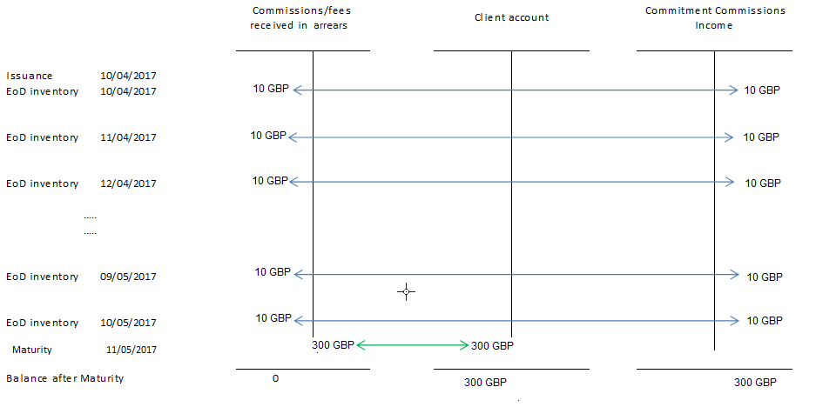

The following illustration is an example of the generated accounting for a periodic commission taken in advance using the default behavior of posting accruals.

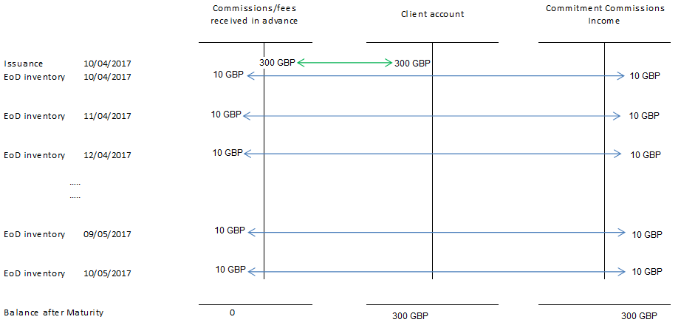

The above examples show that the transaction has a periodic charge amounting to 300 GBP. The first illustration shows that for a periodic charge in arrears, the total accrued amount is posted to the client’s account at maturity.

The second illustration shows that for a periodic charge in advance, the full amount is posted to the client’s account at issuance. Both the examples show that 10 GBP is being credited on a daily basis until maturity.

The accrual posting behavior explained in the illustrations above show the default behavior of the system as regards to posting accruals. However, this is replaced by “Cancel and replace” behavior when Branch system option ‘PerdChgAccrualCancelReplace’ is set to ‘Yes’. The “Cancel and replace” behavior posts the accumulated accruals to date and reverses previously posted accrued amounts, instead of posting the same amount daily as what the default functionality does.

The illustration below shows an example of the generated accounting for a periodic commission taken in arrears when Branch system option ‘PerdChgAccrualCancelReplace’ is set to ‘Yes’.

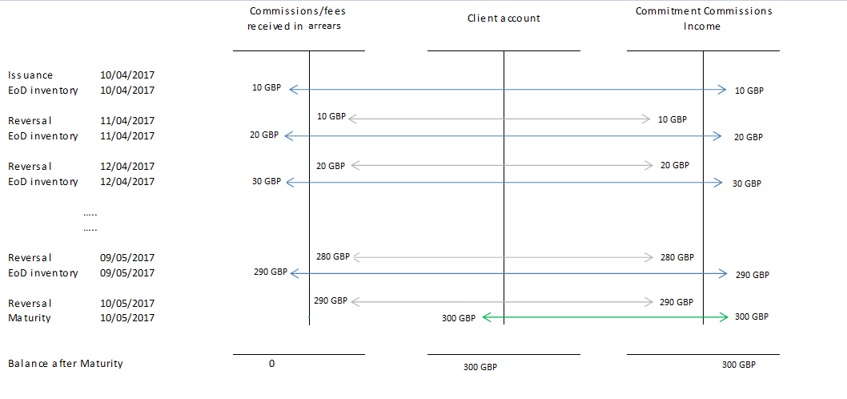

The illustration below shows an example of the generated accounting for a periodic commission taken in advance when Branch system option ‘PerdChgAccrualCancelReplace’ is set to ‘Yes’.

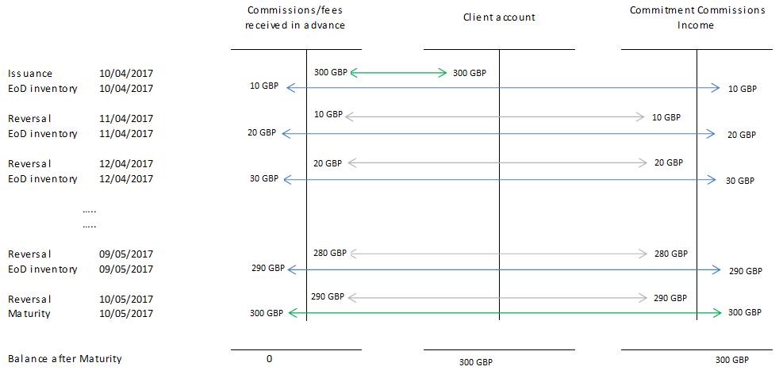

The example above shows that daily accrual amount 10 GBP is posted but was reversed on the next day. However, the accumulated daily accrual amount for two days, 20 GBP, is posted on the second day. The process of reversing the previously posted amount and replacing it with the accumulated daily accrual amount is done on a day by day basis until maturity. The amount of 300 GBP is posted at maturity. It can be easily identified that 300 GBP is the total accrued amount for the cycle because previously posted amounts are reversed.

The posting of the total accrued amount for periodic charges in advance and arrears are the same for default accrual posting behavior and the cancel-replace behavior.

### Interbranch Charges

When an interbranch charge is taken for a non-periodic charge, the system debits the behalf of branch and credits the input branch's profit and loss account.

1. The behalf of branch and input branch must be accounted for under the same Main Banking Entity for interbranch charges. See the Global Processing Implementation Guide – Trade Innovation for a description of Main Banking Entity (MBE)

|  |  |  |  |  |
| --- | --- | --- | --- | --- |
| DR/CR | Account | Amount | Date | Currency |
| DR | Behalf of branch Charge code profit and loss | Charge amount | Charge date | Charge currency |
| CR | Input branch charge Code profit and loss | Charge amount | Charge date | Charge currency |

When a periodic charge is split, the following postings are generated. The split fee amount that is accrued or amortised is posted to the behalf of branch profit and loss and input branch profit and loss accounts on a daily basis so as to split the commission:

|  |  |  |  |  |
| --- | --- | --- | --- | --- |
| DR/CR | Account | Amount | Date | Currency |
| DR | Behalf of branch Charge code profit and loss | Daily charge accrual | Daily | Charge currency |
| CR | Input branch charge Code profit and loss | Daily charge accrual | Daily | Charge currency |

## Billed Charges

When a charge is to be billed, rather than taken now, the system debits a billing account instead of the customer settlement account. The profit is booked immediately or deferred until the charge is paid using a nominated system account.

When the charge is incurred the following postings occur if the charge is to be booked to profit and loss now:

|  |  |  |  |  |
| --- | --- | --- | --- | --- |
| DR/CR | Account | Amount | Date | Currency |
| DR | Customer billed charges receivable (BR) | Charge amount in original currency | Billed charge date | Original currency |
| CR | Charge code profit & loss | Charge amount in booking currency | Billed charge date | Booking currency |

If the charge is not to be booked to profit and loss now then the credit posting is as follows:

|  |  |  |  |  |
| --- | --- | --- | --- | --- |
| DR/CR | Account | Amount | Date | Currency |
| CR | SP661 | Charge amount in booking currency | Billed charge date | Booking currency |

Where the charge currency and the booking currency differ there will also be foreign exchange postings across the SP101 accounts to convert to the charge booking currency (see page 24).

On the day that the customer is to pay the charges the following postings occur:

|  |  |  |  |  |
| --- | --- | --- | --- | --- |
| DR/CR | Account | Amount | Date | Currency |
| DR | Charge payer settlement | Charge amount in original currency | Charge payment date | Original currency |
| CR | Customer billed charges receivable (BR) | Charge amount in original currency | Charge payment date | Original currency |

If the charge was not booked to profit and loss then additional postings are as follows:

|  |  |  |  |  |
| --- | --- | --- | --- | --- |
| DR/CR | Account | Amount | Date | Currency |
| DR | SP661 | Charge amount in booking currency | Charge payment date | Booking currency |
| CR | Charge code profit & loss | Charge amount in booking currency | Charge payment date | Booking currency |

In the examples above the account type (BR) and the system parameter (SP661) are taken from the settings that your bank defines on the product options for each product.

## Expected Income from Deferred Charges

When a charge is deferred to be paid at a later date, your bank can opt to post that charge as expected income. You specify this by setting the zone system option **DfrChgAsExpectedIncome** to Yes. See the System Tailoring User Guide – Trade Innovation for details.

These charges are accounted for in the following way when the charge is incurred:

|  |  |  |  |  |
| --- | --- | --- | --- | --- |
| DR/CR | Account | Amount | Date | Currency |
| DR | Customer expected charge receivable (YC) | Charge amount | Deferred charge date | Charge currency |
| CR | Charge profit and loss | Charge amount | Deferred charge date | Booking currency |

Where the charge currency and the booking currency differ there will also be foreign exchange postings across the SP101 accounts to convert to the charge booking currency (see page 24).

Once the charge is flagged to be taken, the following postings will occur:

|  |  |  |  |  |
| --- | --- | --- | --- | --- |
| DR/CR | Account | Amount | Date | Currency |
| CR | Customer expected charge receivable (YC) | Charge amount | Charge payment date | Charge currency |
| DR | Charge payer settlement | Charge amount | Charge payment date | Charge currency |

# Postings

This chapter identifies the prerequisite static data required to support postings in the system.

## Posting Sets

The system permits you to define the postings to be generated for each event in the life-cycle of a product. These postings can be used to record:

* Initial and subsequent changes to liability to customer and internal contingent liability accounts for the event or payments
* Details of any collateral held or margin deposits taken
* Details of any advances made
* The movements of real funds, such as payment of funds through a nostro for an advising bank or receipt of funds from the applicant. Postings to such accounts also have pay and receive settlements details associated with them, obtained from standing settlement instructions. These provide information to the system on how funds are to be transferred and on the advices to be issued
* Foreign exchange and discount interest. Trade finance activity can result in the generation of a foreign exchange deal or financing deal. For example, the beneficiary may wish to be paid in a currency that is different from that of the letter of credit. Similarly, an acceptance may be discounted, resulting in an early payment of principal
* Repayments of principal and interest

## Prerequisite Static Data for Postings

The system uses a number of parameters to construct accounts for postings. This section lists the posting parameters that the system uses, describes the properties they require and explains how these properties are implemented.

The types of parameter that support postings are:

* System parameters (SP)
* Account types

The system parameters and account types used by the system are provided as standard data sets, which can be tailored to your bank's requirements using the static data application.

See the Static Data Maintenance User Guide – Trade Innovation for information on account maintenance.

### System Parameters

The system parameters used to support the system postings can be divided into two groups on the basis of their properties. The first group covers suspense and reconciliation accounts e.g. SP500, SP503, SP148 and the second liability accounts e.g. SP501, SP505, SP509.

The first group must each have an account type defined for customer related suspense accounts – this must be:

* an on balance-sheet account type and category code
* be internal, valid for funds movements, and not contingent
* have transaction codes valid for internal and funds settlement accounts

The following table lists parameters in this first group. These must be set up using the codes shown:

|  |  |  |
| --- | --- | --- |
| Code | Description | Purpose |
| SP148 | Settlement in Error Suspense | Used to record postings where the account retrieved from standing settlement instructions is invalid. |
| SP500 | TF settlement suspense | Used to account for trade finance settlements where no specific settlement instructions have been defined for the relevant party. |
| SP503 | TF exchange reconciliation | Used as the reconciliation point between the postings generated by the system and those generated by the corresponding foreign exchange deals passed to the back office. |
| SP504 | TF term reconciliation | Used as the reconciliation point between the postings generated by the system and those generated by the corresponding money market deals passed to the back office. |
| SP508 | Sundry posting in error | Used to record postings where an error occurred when attempting to post to an account, because either:   * The account was blocked * The balance of the account was exceeded |
| SP539 | Split value date suspense | Used to ensure postings balance by currency where there are split value date entries.  Entries to this account are typically generated where:   * the purchase and sale value dates differ ona foreign exchange deal * other bank’s charges are not for the same value date * clean payments where the receipt and payment of funds are on different days   Additionally, where the bank is using PostReleaseDays to determine when future dated items are posted the system may release postings on different value dates. To cater for this, the bank may need to define additional posting rules against this account to ensure that postings balance by value date. |

The second group must each have:

* Account types and category code for below-the-line contingent accounts
* An account type that is defined as internal and contingent
* Transaction codes valid for internal and contingent accounts

The tables in the following sub-sections list parameters in this second group organised according to the product that uses them.

#### Cash Letters

The following table shows the additional system parameters reserved for cash letters accounting:

|  |  |  |
| --- | --- | --- |
| Code | Description | Purpose |
| SP672 | Finance cash letter advance payment | For financing negotiated cash letter payment in advance. |
| SP673 | Our cheque settlement suspense | For settling own cheques through suspense. This is only required for inward cash letters. |
| SP674 | Cheque clearing settlement suspense | For clearing cheques through suspense. |
| SP675 | Cash letter negotiation contra | For negotiated payment contra liability. This is only required for outward cash letters if you plan to record negotiated payment liability. |

#### Clean Banker's Acceptances

The following table shows the additional system parameters reserved for clean banker's acceptance account postings:

|  |  |  |
| --- | --- | --- |
| Code | Description | Purpose |
| SP670 | TF banker's acceptance liability | For banker's acceptance contra liability. |
| SP671 | BA settlement suspense | For settling acceptance or acceptance purchased through suspense. |

#### Clean Payments

The following table shows the additional system parameters reserved for clean payments accounting:

|  |  |  |
| --- | --- | --- |
| Code | Description | Purpose |
| SP538 | Clean Payment Settlement Suspense | Used to account for clean payments where no specific settlement instructions are defined for a party to the transaction. |
| SP539 | Split value date suspense | Used to account for foreign exchange-related settlements where the purchase and sale value dates differ. |

#### Collection Orders

The following table shows the system parameters reserved for collection order accounting:

|  |  |  |
| --- | --- | --- |
| Code | Description | Purpose |
| SP509 | Avalised collection liability | Used to provide a contra account for avalised collections in each currency. The account is used as the contra for postings to the customer avalised collection liability account. |
| SP516 | Other collection 1 | Used to provide a general-purpose contra account for collections in each currency, for example for additional collection liability. |
| SP517 | Other collection 2 | Used to provide a general-purpose contra account for collections in each currency, for example for additional collection liability. |

#### Financing

The following table shows the additional system parameters reserved for financing interest accounting:

|  |  |  |
| --- | --- | --- |
| Code | Description | Purpose |
| SP625 | Transit interest | Used to provide a profit and loss account for transit interest. |
| SP626 | Interest income | Used to provide a profit and loss account for interest income. |
| SP627 | Interest receivable | Used to provide a receivable account for interest in arrears. |
| SP628 | Advance interest received | Used to provide an unearned income account for income in arrears. |
| SP629 | Past due interest income | Used to provide a profit and loss account for past due interest income. |
| SP630 | Past due interest receivable | Used to provide a receivable account for part due interest. |
| SP631-644 | User's own use | Available for your bank's own purposes. |

If you intend to participate loans then the following additional system parameters are required to handle the interest due to the participants:

|  |  |  |
| --- | --- | --- |
| Code | Description | Purpose |
| SP656 | Interest expenses | Used to provide a profit and loss account for expenses payable to participants. |
| SP657 | Interest payable | Used to provide a payable account for interest in arrears due to participants. |
| SP658 | Advance interest payable | Used for unearned expenses for interest in advance due to participants. |
| SP659 | Past due interest expenses | Used to provide a payable account for past due interest income due to participants. |
| SP660 | Past due interest payable | Used for unearned expenses for past due interest due to participants. |

#### Letters of Credit

The following table shows the system parameters reserved for letters of credit accounting:

|  |  |  |
| --- | --- | --- |
| Code | Description | Purpose |
| SP501 | LC issuance liability | Used to provide a contra account for letters of credit the bank has issued (import letters of credit) in each currency. The account is used as a contra for postings to the customer letter of credit account. |
| SP502 | Confirmed LC liability | Used to provide a contra account for advised letters of credit (export letters of credit) in each currency. The account is used as a contra for postings to the customer letter of credit account. |
| SP505 | TF acceptance liability | Used to provide a contra account for acceptance payments made by the bank. Postings are generated to record the acceptance liability against a customer contingency account with a contra entry to SP505. |
| SP506 | Confirmed LC liability (other) | Used as an alternative to SP502 if the bank wishes to distinguish between two types of letter of credit, for example between those issued at sight and at usance. |
| SP507 | TF acceptance liability (other) | Used as an alternative to SP505. |
| SP519 | LC issuance liability (other) | Used as an alternative to SP501. |

#### Participations

The following table shows the system parameters reserved for participation deal accounting:

|  |  |  |
| --- | --- | --- |
| Code | Description | Purpose |
| SP662 | Participation commitment liability | Used to provide a contra account for any commitment liability recorded for a participation deal. |

#### Reimbursements

The following table shows the system parameters reserved for reimbursement accounting:

|  |  |  |
| --- | --- | --- |
| Code | Description | Purpose |
| SP530 | Reimbursement undertaking liability | Used to provide a contra account for reimbursement authorisations where the bank has added their confirmation. |
| SP531 | Reimbursement acceptance liability | Used to provide a contra account for reimbursement authorisations where the bank has accepted a draft. |
| SP532 | Reimbursement payment liability 1 | Used to provide a general-purpose contra account for reimbursement authorisations which your bank can use for its own categorisation purposes. |
| SP533 | Reimbursement payment liability 2 | Used to provide a general-purpose contra account for reimbursement authorisations which your bank can use for its own categorisation purposes. |

#### Standby Letters of Credit and Guarantees

The following table shows the system parameters reserved for accounting for standby letters of credit and guarantees:

|  |  |  |
| --- | --- | --- |
| Code | Description | Purpose |
| SP510 | SB contra liability | Used to provide a contra account for standby letters of credit the bank has issued in each currency. The account is used as a contra for postings to the customer standby account. |
| SP511 | GR contra liability | Used to provide a contra account for guarantees the bank has issued in each currency. The account is used as a contra for postings to the customer guarantee account. |
| SP512 | Confirmed SB liability | Used to provide a contra account for export standby letters of credit in each currency. The account is used as a contra for postings to the customer standby account. |
| SP513 | Confirmed GR liability | Used to provide a contra account for export guarantees in each currency. The account is used as a contra for postings to the customer guarantee account. |

### Account Types

The system uses account types to control characteristics of accounts, such as whether or not the account is contingent.

The following tables provide examples of the account types that must be set up for use by the system.

These tables use the following abbreviations:

|  |  |
| --- | --- |
| Parameter | What It Is Used For |
| Ctgt | Contingent |
| Int | Internal |
| Funds | Valid for funds settlement |

#### Accounts for Clean Banker's Acceptances

The following table shows the additional account types used to support clean banker's acceptance account postings:

|  |  |  |  |  |  |
| --- | --- | --- | --- | --- | --- |
| Code | Description | Ctgt | Int | Funds | Purpose |
| RQ | Banker's acceptances | Yes | No | No | Account used for banker's acceptance liability against the obligor. |
| TU | BAs- bank shared liability | Yes | Yes | No | Account used for bank shared acceptance liability. |
| M3 | Financing BA purchase | No | No | No | Account used for banker's acceptance purchased liability against the obligor. |

#### Accounts for Cash Letters

The following table shows the additional account types used to support cash letters liability postings:

|  |  |  |  |  |  |
| --- | --- | --- | --- | --- | --- |
| Code | Description | Ctgt | Int | Funds | Purpose |
| TE | Cash letter negotiation liability | No | No | No | Account used for negotiated payment liability. This is only required for outward cash letters if you plan to record negotiated payment liability. |
| TF | Cash letter negotiation contra | No | Yes | No | The contra to the above account. |

#### Asset Accounts for Financing

The following table shows the additional account type reserved for financing interest accounting:

|  |  |  |  |  |  |
| --- | --- | --- | --- | --- | --- |
| Code | Description | Ctgt | Int | Funds | Purpose |
| YU | Advance interest receivable | No | Yes | No | Account used to record the amount of interest collected in advance and not yet amortised to P/L. |

The following table shows the additional account types reserved for financing loan booking:

|  |  |  |  |  |  |
| --- | --- | --- | --- | --- | --- |
| Code | Description | Ctgt | Int | Funds | Purpose |
| L1 | Standalone import financing | No | No | No | Account used to book the outstanding import financing provided by the bank which is not directly related to another trade finance transaction. |
| L2 | Standalone export financing | No | No | No | Account used to book the outstanding export financing provided by the bank which is not directly related to another trade finance transaction. |
| L3 | Import financing under L/C and L/G | No | No | No | Account used to book the outstanding financing provided by the bank to the applicant for the settlement of a letter of credit or guarantee. |
| L4 | Export financing under L/C and L/G | No | No | No | Account used to book the outstanding financing provided by the bank to the beneficiary of a letter of credit or letter of guarantee (for example, export bills purchase or financing of an export bill under L/C on collection). |
| L5 | Import financing under collection | No | No | No | Account used to book the outstanding financing provided by the bank to the applicant for the settlement of a collection order. |
| L6 | Export financing under collection | No | No | No | Account used to book the outstanding financing provided by the bank to the drawer of a collection order prior to the receipt of funds due. |
| L7 | Trust receipt financing | No | No | No | As for L3 above, but under trust receipt. |
| L8 | Past due import loans | No | No | No | Account used to book the outstanding balances of past due import loans. An automatic transfer (on x days after due date) function is available if required. |
| L9 | Past due export loans | No | No | No | Account used to book the outstanding balances of past due export loans. An automatic transfer (on x days after due date) function is available if required. |

#### Collection Orders

The following table shows the account types used by the standard posting set for collection orders:

|  |  |  |  |  |  |
| --- | --- | --- | --- | --- | --- |
| Code | Description | Ctgt | Int | Funds | Purpose |
| RJ | Avalised collection | Yes | No | No | Accounts used to book liability when the bank avalises drafts due for an inward collection, guaranteeing to honour payment at the maturity of the draft. These accounts are debited when the bills are accepted and avalised, and are credited when payment is made. |
| TJ | Liability - avalised collection | Yes | Yes | No | Bulk contra to RJ - Avalised Collection. The account balances will all be credit. |

#### Current Accounts

|  |  |  |  |  |  |
| --- | --- | --- | --- | --- | --- |
| Code | Description | Ctgt | Int | Funds | Purpose |
| CA | Current account | No | No | Yes | Customer accounts with the bank that are due on demand. |
| CN | Nostro account | No | No | Yes | Accounts that the bank has with other banks. |
| CV | Vostro account | No | No | Yes | Accounts of other banks with the bank. |

#### General Deposits (Customers)

|  |  |  |  |  |  |
| --- | --- | --- | --- | --- | --- |
| Code | Description | Ctgt | Int | Funds | Purpose |
| DI | Collateral deposits | No | No | No | Deposits held by the bank to satisfy collateral requirements. |
| DJ | Margin deposit | No | No | Yes | Deposits held by the bank to satisfy margin requirements, for example for letters of credit, loans, or forward foreign exchange sales. |

#### Letters of Credit

The following table shows the account types used by the standard posting set for letters of credit:

|  |  |  |  |  |  |
| --- | --- | --- | --- | --- | --- |
| Code | Description | Ctgt | Int | Funds | Purpose |
| RA | Letter of credit issued | Yes | No | No | Accounts used to record import letters of credit issued by the bank. These accounts are debited when the letter of credit is issued, and credited when payment is made under its terms or when it expires. |
| RB | Letter of credit issued  (other) | Yes | No | No | Used as an alternative to RA if the bank wishes to distinguish between two types of letter of credit, for example between those issued at sight and at usance. |
| RC | Letter of credit confirmed | Yes | No | No | Accounts used to record the bank's commitment to honour payment when documents are presented under an export letter of credit. By confirming the credit, the bank assumes a contingent liability on behalf of the issuing bank. These accounts are debited when credit is confirmed by advising the export letter of credit, and are credited when payment is made. |
| RD | Letter of credit confirmed (other) | Yes | No | No | Used as an alternative to RC if the bank wishes to distinguish between two types of letter of credit, for example between those issued at sight and at usance. |
| RH | Acceptances | Yes | No | No | Accounts used to record acceptance payments that are to be made by the bank. The accounts are in the name of the issuing bank. As an acceptance payment is recorded, the letter of credit confirmed liability is reduced. The acceptances may be discounted, creating above-the-line accounts. The account is debited as the draft is accepted, and is credited when the draft is discounted or is paid. |
| TA | Liability - letter of credit Issued | Yes | Yes | No | Bulk contra to RA - Letter of Credit Issued. The account balances will all be credit. |
| TB | Liability - letter of credit issued (other) | Yes | Yes | No | Bulk contra to RB - Letter of Credit Issued (Other) The account balances will all be credit. |
| TC | Liability - letter of credit confirmed | Yes | Yes | No | Bulk contra to RC - Letter of Credit Confirmed The account balances will all be credit. |
| TD | Liability - letter of credit confirmed (Other) | Yes | Yes | No | Bulk contra to RD - Letter of Credit Confirmed (Other) The account balances will all be credit. |
| TH | Liability – acceptances | Yes | Yes | No | Bulk contra to RH - Acceptances The account balances will all be credit. |

#### Participations

The following table shows the account types used by the standard posting set for participation deals:

|  |  |  |  |  |  |
| --- | --- | --- | --- | --- | --- |
| Code | Description | Ctgt | Int | Funds | Purpose |
| RP | Participation commitment | Yes | No | No | Accounts used to record participation deal commitments for the bank. These accounts are debited when initial commitment is made and credited as the commitment is drawn down. |
| TS | LCs - bank shared liability | Yes | Yes | No | Accounts used to record any risk participated out by the bank. These accounts are credited when the risk is incurred and debited when the risk is paid off or expired. |
| TT | LCs - acceptance shared liability | Yes | Yes | No | Accounts used to record any acceptance risk participated out by the bank. These accounts are credited when the risk is incurred and debited when acceptance is paid off. |
| T9 | Liability - participation commitment | Yes | Yes | No | Bulk contra to RP - Participation Commitment. The account balance will be credit. |

#### Reimbursements

The following table shows the account types used by the standard postings set for reimbursements. The account types details such as the basic account number range and suffix range are required to be reviewed and changed in line with the bank's accounting requirements:

|  |  |  |  |  |  |
| --- | --- | --- | --- | --- | --- |
| Code | Description | Ctgt | Int | Funds | Purpose |
| R5 | Sight reimbursement undertaking | Yes | No | No | Accounts used to record sight reimbursement undertaking liability against the issuer. |
| R6 | Usance reimbursement undertaking | Yes | No | No | Accounts used to record usance reimbursement undertaking liability against the issuer. |
| R7 | Reimbursement acceptances | Yes | No | No | Accounts used to record acceptance liability against the issuer. |
| R8 | Reimbursement payment liability 1 | Yes | No | No | Accounts used to record payment (sight and deferred) liability against the issuer when a claim is completed with the value date set to a future date. |
| R9 | Reimbursement payment liability 2 | Yes | No | No | A spare account type which can be used, for example, to record deferred payment liability against the issuer, if your bank uses R8 only for sight payment. |
| T5 | Reimbursement undertaking | Yes | Yes | No | Accounts used to record contra reimbursement undertaking liability (sight and usance). |
| T6 | Reimbursement acceptances | Yes | Yes | No | Accounts used to record contra acceptance liability. |
| T7 | Reimbursement payment liability 1 | Yes | Yes | No | Accounts used to record contra payment (sight and deferred) liability. |
| T8 | Reimbursement payment liability 2 (spare) | Yes | Yes | No | Spare account type which can be used to record contra deferred payment liability if your bank uses T7 for sight payment liability only. |
| M1 | Financing under reimbursements | No | No | No | Accounts used to record outstanding finance provided by the bank. |
| M2 | Financing under reimbursement 2 (spare) | No | No | No | Spare account type which can be used to record a different type of outstanding finance if M1 is not used for all types. For example, your bank could use M1 for finance to the claimant or presenter, and M2 for finance to the issuer. |

#### Standby Letters of Credit and Guarantees

The following table shows the account types used by the standard posting set for standby letters of credit and guarantees:

|  |  |  |  |  |  |
| --- | --- | --- | --- | --- | --- |
| Code | Description | Ctgt | Int | Funds | Purpose |
| RS | Standbys - bank shared liability | Yes | Yes | No | Accounts used to record any risk participated out by the bank. These accounts are credited when the risk is incurred and debited when the risk is paid off or expired. |
| RT | Guarantees - bank shared liability | Yes | Yes | No | Accounts used to record any risk participated out by the bank. These accounts are credited when the risk is incurred and debited when the risk is paid off or expired. |
| R1 | Standby issued | Yes | No | No | Accounts used to record import standby letters of credit issued by the bank. These accounts are debited when the standby is issued, and credited when payment is made under its terms or when it expires. |
| R2 | Guarantee issued | Yes | No | No | Accounts used to record import guarantees issued by the bank. These accounts are debited when the guarantee is issued, and credited when payment is made under its terms or when it expires. |
| R3 | Standby confirmed | Yes | No | No | Accounts used to record the bank's commitment to honour payment when documents are presented under an export standby. By confirming the credit, the bank assumes a contingent liability on behalf of the issuing bank. These accounts are debited when credit is confirmed by advising the export standby, and are credited when payment is made. |
| R4 | Guarantee confirmed | Yes | No | No | Accounts used to record the bank's commitment to honour payment when documents are presented under an export guarantee. By confirming the credit, the bank assumes a contingent liability on behalf of the issuing bank. These accounts are debited when credit is confirmed by advising the export guarantee, and are credited when payment is made. |
| T1 | Liability - standby issued | Yes | Yes | No | Bulk contra to R1 - Standby Issued. The account balances will all be credit. |
| T2 | Liability - guarantee issued | Yes | Yes | No | Bulk contra to R2 - Guarantee Issued The account balances will all be credit. |
| T3 | Liability - standby confirmed | Yes | Yes | No | Bulk contra to R3 - Standby Confirmed The account balances will all be credit. |
| T4 | Liability - guarantee confirmed | Yes | Yes | No | Bulk contra to R4 - Guarantee Confirmed The account balances will all be credit. |

#### Suspense Accounts

The following table shows the additional account type reserved for suspense accounting:

|  |  |  |  |  |  |
| --- | --- | --- | --- | --- | --- |
| Code | Description | Ctgt | Int | Funds | Purpose |
| YS | Suspense Default | No | No | Yes | Accounts used for settlement postings where no customer account, vostro or nostro has been specified. |

### Reconciliation of Postings with the Back Office General Ledger

In general, the system simply handles the basic account postings associated with trade finance activities. It generates value dated postings to record liability and handles all postings relating to the payment and receipt of funds for an event. If you have the financing module implemented, the system also handles the necessary interest accruals and amortisations.

The system does not however handle the processing of currency exchange positions arising from foreign exchange dealing activities. The system requires these details to be handled by the back office system, as for the bank’s other foreign exchange deals.

If you do not have the financing module implemented, it also expects money market activity to be handled by the back office. These can be handled either by processing the deal details directly and generating the required accounting or via deal tickets. How this is done depends on the back office system used and on how the back office processes money market deals and their associated postings.

The system expects the foreign exchange and money market deals to be reconciled via two special internal reconciliation accounts defined on Product options, these are typically set to SP503 and SP504. The posting entries within the system handle the funds movements, with contra entries being passed to the reconciliation accounts from which the necessary back office deal is funded.

1. If you are keying deals into aback office system Finastra recommends that you settle them using accounts equivalent to the SP503 and SP504 accounts. The default posting sets supplied with the system assume that you do so and pass relevant postings whenever a foreign exchange or financing deal is generated.

When considering the implications for back office reconciliation, the processing of the items listed in the table on the following page needs to be reviewed, to ensure they are handled appropriately. If you have implemented the financing module, you do not need to review money market deals, money market deal maintenance, or repayments.

|  |  |
| --- | --- |
| Item | Description |
| Postings | Debit and credit postings with a value date of today or earlier. |
| Projections | Future dated projections of funds movements that can be included in cash and nostro positions for reporting purposes. |
| Maturity | The actual postings of funds movements as a projection's value date is reached. These items are generated during batch processing. |
| Foreign exchange deals | Depending on how system options are set, the system will either pass details of foreign exchange deals directly to the back office, generate postings directly to exchange position accounts, or produce deal tickets. The deal details include the exchange rate used, the sale and purchase amounts and currencies, and the relevant value dates. |
| Money market deals | Depending on how system options are set, the system will either pass details of money market deals to the back office or produce deal tickets.  There are two types of money market deal generated from finance deals:   * Discount deals, where interest (discount) is to be paid at the deal inception. The deal details include: * Deal start date * Deal maturity date * Deal interest rate (including spread) * Interest days basis * Whether discount is to be calculated using the standard formula or the yield formula. This is determined by the deal type * Whether extra days interest applies. This is determined by the deal type * Non-discount deals, where interest is paid at maturity (with the option of interim interest being paid). The deal details include: * Deal start date * Deal maturity date (or 'open', if unknown) * Deal interest rate (including spread) * Interest days basis * Whether extra days interest applies. This is determined by the deal type |
| Money market maintenance | Only deals with interest at maturity are maintained.  The system generates money market deal maintenance as a result of:   * The next interest due date being entered as part of a repayment transaction when interim interest is to be paid * The maturity date of a deal being changed |
| Money market deal repayments | Money market deal repayments are generated when principal is repaid against a money market deal. The information passed to the back office includes:   * The amount paid * The value date of the payment |

Foreign exchange deals can be handled in any of the following ways:

* By implementing an interface which automatically passes foreign exchange deals to the back office system using the foreign exchange deal interface service
* By using the deal tickets produced by the system to key the details manually into your back office system
* By generating postings to exchange position accounts, and implementing an interface to the back office system using the service interface messages. Given that most systems hold exchange positions differently, this interface will need to take the system’s SP101 postings and use them to generate all the details required to represent the exchange positions in the back office system
* If you do not have the financing module implemented, money market deals can be handled in either of the following ways
* By implementing an interface which automatically passes money market deals, maintenance and repayments to the back office system using the money market deal interface service
* By using the deal tickets produced by the system to key the details manually into your back office system to reconcile with Trade Innovation postings

# Financing Interest Processing

## Financing Interest

The interest rate to be charged for a particular financing transaction will depend on a variety of factors, including:

* Currency
* The size and duration of the loan
* Base rate type, such as LIBOR, Prime, HIBOR or a specific bank base rate
* Duration of the loan
* Risk, for example whether the loan is with or without security
* Application of interpolation on interbank offered rates

The interest rate quoted, sometimes as part of the account opening agreement with corporate clients, will normally be expressed as a type of base rate plus margin, for example LIBOR plus 1.5% or bank base rate plus 0.5%. The actual rate charged for finance will therefore be the actual rate attached to the base rate type at the time of the loan plus the margin specified.

For detailed instructions on using the system to set up interest rate mapping see the System Tailoring User Guide – Trade Innovation.

### The Base Rate

The type of base rate to be used will typically depend on the currency and duration of the transaction. For example:

* GBP loans up to 30 days can be linked to the bank base rate
* GBP loans up to 3 months can be linked to LIBOR
* GBP loans over 3 months can be linked to the '3 month LIBOR'
* USD loans can be linked to USD Prime
* HKD loans can be linked to HIBOR

and so on.

### Margins

The margin applied will typically depend on the borrower's credit standing, the size of the loan, the risk involved, and the competitiveness of the market place.

For example:

* FTSE 100, Eurotop 300 and Fortune 500 companies may be charged only 0.5% (or less) margin above the base rate
* A small PLC may be charged 3-5% above the base rate
* And a small sole trader may be charged 7-10% above the base rate

Other factors may affect the size of the margin. For example, financing such as a trust receipt loan where the bank has the title of the goods, may be charged a lower margin than an import bills receivable (IBR) loan where the bank does not have title; and a £1,000 GBP loan will normally be charged at a higher margin than a £10,000,000 GBP loan.

For example, for a FTSE 100 company the interest rate agreed could be as follows:

* Short term (up to 30 days) import loans is LIBOR plus 1.0 % margin
* Medium term (31 to 90 days) import loan is LIBOR plus 1.5%
* Long term (over 90 days) import loan is 3Month Libor plus 2%
* All trust receipt loans as bank base rate plus 0.5%

For a small PLC, it could be as follows:

* Short term (up to 30 days) import loans is bank base rate plus 5.0 % margin
* Medium term (31 to 90 days) import loan is bank base rate plus 5.5%
* Long term (over 90 days) import loan is bank base rate plus 6%
* All trust receipt loans as bank base rate plus 4.0%

## Setting up Interest Rates

The interest rate mapping functions provided with the system allow your bank to define the different rates to be used, and the circumstances in which each rate should be used, in accordance with your bank's interest rate policy. Once interest rate mapping has been defined, the system will be able to assign an interest rate automatically, according to the characteristics of the transaction.

The system uses the base rates and differential rates set up for your system during the process of defining interest rate mapping. You must set these up using the static data maintenance application - instructions are given in the Static Data Maintenance User Guide – Trade Innovation.

### Base Rates

Base rates are defined as a unique two-character code and associated description, and the relevant rate for that particular rate. For example:

|  |  |  |
| --- | --- | --- |
| Code | Description | Rate |
| G1 | LIBOR | 5.50 |
| G2 | 3 Months LIBOR | 6.00 |
| G4 | GBP bank base rate | 7.00 |
| U1 | USD Prime | 5.50 |
| H1 | HIBOR | 8.00 |

### Differential Rates

Differential rates can be applied in one of two ways:

* As a specific rate entered either onto the schedules used to calculate interest, or during transaction processing
* As a code which corresponds to a differential rate stored as part of your system's static data. Each differential rate is defined as a unique two-character code, a description, and the differential rate to be applied

If a financing agreement specifies that all trust receipt loans for that customer are to be charged at 0.5% above LIBOR, the differential rate can be entered as an actual rate on the schedules set up for that customer, or on financing transactions for that customer as they are created on your system. There is no need in such a case to use a static data differential rate.

Differential rates are useful, however, for variable differential rates that may be applicable to a group of customers. For differential rates used in this way, you are advised to set up a differential rate and attach it via interest rate mapping to the relevant financing transactions. As the differential rate changes, the effect is reflected automatically in the interest calculations for all affected financing transactions.

For example, you bank may set up a penalty premium differential rate to be applied to loans that are not fully repaid on the due date. The penalty premium differential rate is determined by the bank and can be changed without notice. The penalty premium can be defined as a differential rate of 2% and attached to transactions, via interest rate mapping, as a code rather than an actual fixed rate. If your bank decides to change the rate to 4%, you need only change the rate in one place - the differential rate definition - for all transactions using that differential rate to begin using the new rate automatically for the effective rate change date onwards.

## Interpolation of Interbank Offered Rates

Financial market participants often use interpolation methods, including linear interpolation to determine the value of missing interest rates on a yield curve. For example, assume that a bank needs to determine a USD Libor rate with a maturity of 1.5 months (45 days).

|  |  |
| --- | --- |
| Period | Rate |
| 1 day | 0.0068667 |
| 1 week | 0.0071972 |
| 1 month | 0.0077167 |
| 2 months | 0.0083833 |
| 3 months | 0.0103372 |
| 6 months | 0.0133794 |
| 1 year | 0.0170011 |

Using the rates defined in the table above; there is no current Libor quote available for the required maturity of 1.5 months, so it is necessary to estimate the unknown rate by means of linear interpolation.

Trade Innovation only supports linear interpolation for interests that have fixed rates and are based by period. Base rate to be used should also be defined as interbank offered rate.

The general formula used for interpolation is:



where:

|  |  |
| --- | --- |
| $t_{1}$ | = days to maturity of R1 |
| $$R_{1}$$ | = rate with shorter maturity |
| $$t_{2}$$ | = days to maturity of R2 |
| $$R_{2}$$ | = rate with longer maturity |
| $$t_{n}$$ | = days to maturity of the unknown rate |
| $$R_{n}$$ | = Unknown rate between R1 and R2 (?) |

Given the formula and data provided above, the system calculates the interest rate for 1.5 months (45 days) using define rates for 1 month (30 days) and 2 months (60 days).

$R_{n}=0.0077167 + \frac{0.0083833 -0.0077167}{60-30} x (45-30)$

$$R_{n}=0.0077167 + \frac{0.00066660}{30} x (15)$$

$$R_{n}=0.0077167 +0.00002222 x 15$$

$$R_{n}= 0.0077167 + 0.0003333$$

$$R_{n}= 0.00805$$

Following the calculation above, the system uses 0.00805 as the interest rate in this scenario.

## Interest Types

Banks which provide trade-related financing as a standard service may have either a published standard tariff or an internal guideline for their account managers, which provides a list of financing types and their corresponding interest rate policy. This is equivalent to the price list of trade-related financing products of the bank. The table below shows how such a guideline might be structured:

| Product Type | Criteria | Currency | Base Rate Type | Tier | Differential |
| --- | --- | --- | --- | --- | --- |
| Import bills receivable |  | GBP | Bank base rate | up to 50,000 | plus 5% |
|  |  | GBP | Bank base rate | over 50,000 | 4% |
|  |  | USD | Prime |  | plus 6% |
| Trust receipt loans | up to 90 days | GBP | Bank base rate | up to 50,000 | plus 3% |
|  | up to 90 days | GBP | Bank base rate | over 50,000 | 2% |
|  | over 90 days | GBP | 3M LIBOR | up to 50,000 | plus 0.5% |
|  | over 90 days | GBP | 3M LIBOR | over 50,000 | 0.3% |
|  |  | USD | Prime |  | plus 5% |
| Other import loans |  | GBP | Bank base rate | up to 50,000 | plus 3% |
|  |  | GBP | Bank base rate | over 50,000 | plus 2% |
|  |  | USD | Prime |  | plus 4% |

The interest types permit you to recreate this structure in the system. Each interest type is set up to represent a generic interest pricing method used by your bank. These interest types can then be mapped to one or more specific products, with rules attached to control when it is applied.

Each interest type has schedules to define the interest rate to be applied, including tiers. For each interest type/product mapping, you can define the system parameters to be used to handle the interest accrual, including profit split by branch. This accounting can also have rules to control when it is applicable.

#### Example

A bank using the guidelines illustrated above would need to set up four different interest types, to cover:

* Import bills receivable - short term
* Import trust receipt loans - short term
* Import trust receipt loans - long term
* Other import loans

The interest types created would each have a unique ID and a description:

|  |  |
| --- | --- |
| ID | Description |
| IBR | Import BR |
| TRSHORT | Import TR Short Term |
| TRLONG | Import TR Long Term |
| IMP | Import Loan |

The bank would then map each of these interest types against the appropriate product using rules to determine when each should be used in the following way:

|  |  |  |
| --- | --- | --- |
| Product | Interest Type | Rules |
| Finance Import LC | Import TR Short Term | Trust receipt = TRUE AND Finance tenor days < 91 |
|  | Import TR Long Term | Trust receipt = TRUE |
|  | Import BR | Finance product type = IBR |
|  | Import Loan |  |

During transaction processing, one of these interest types only will be allocated to the financing transaction. The system will process each of the interest types in turn, in the order in which the bank mapped them against the product, matching the associated rules against the transaction data until it finds a match. It uses the first interest type it encounters where the rules match the data, and does not consider any further interest types in the list. The order in which you enter interest types against products is therefore important.

## Schedules and Interest Types

A bank is likely to have guidelines determining the interest to be charged to individual customers, or customers of a particular type. The table below shows how such a guideline might be structured:

|  |  |  |  |  |  |  |  |
| --- | --- | --- | --- | --- | --- | --- | --- |
| Product Type | Currency | | Criteria | Base Rate Type | North Sea Oil | Eaton & Co. | All other Customers |
| Import bills receivable | | GBP |  | Bank base rate | + 0.5% | + 0.7% | plus 5% |
|  | | USD |  | Prime | + 1.05 | + 1.0% | plus 6% |
| Trust receipt loans | | GBP | up to 90 days | Bank base rate | + 0.5% | + 0.5% | plus 3% |
|  | | GBP | over 90 days | 3M LIBOR |  |  | + 0.5% |
|  | | USD |  | Prime | + 1.0% | + 1.5% | plus 5% |
| Other Import loans | | GBP |  | Bank base rate |  |  | plus 3% |
|  | | USD |  | Prime |  |  | plus 5% |

You recreate this pricing structure by setting up schedules against interest types. The following shows the different schedules that can be set up against interest types to handle the pricing structure illustrated above:

| Schedule | Interest Type | Currency | Customer | Tier 1 Rate | Tier 2 Rate |
| --- | --- | --- | --- | --- | --- |
| 1 | Import BR | GBP |  | Up to 50,000 GBP G4 + 5% | Over 50,000 GBP G4 + 4% |
| 2 |  |  | North Sea Oil | G4 + 0.5% |  |
| 3 |  |  | Eaton & Co. | G4 + 0.7 |  |
| 5 |  | USD |  | U1 + 6% |  |
| 6 |  |  | North Sea Oil | U1 + 1% |  |
| 7 |  |  | Eaton & Co. | U1+ 1% |  |
| 8 | Import TR Short Term | GBP |  | Up to 50,000 GBP G4 + 3% | Over 50,000 GBP G4 + 2% |
| 9 |  |  | North Sea Oil | G4 + 0.5% |  |
| 10 |  |  | Eaton & Co. | G4 + 0.5% |  |
| 12 |  | USD |  | U1 + 5% |  |
| 13 |  |  | North Sea Oil | U1 + 1% |  |
| 14 |  |  | Eaton & Co. | U1 + 1.5% |  |
| 15 | Import TR Long Term | GBP |  | Up to 50,000 GBP G2 + 0.5% | Over 50,000 GBP G2 + 0.3% |
| 16 |  | USD |  | U1 + 5 |  |
| 17 | Import Loan | GBP |  | Up to 50,000 GBP G4 + 3% | Over 50,000 GBP G4 + 2% |
| 18 |  | USD |  | U1 + 5 |  |

During transaction processing, the system will find and apply the appropriate schedule. The input clerk can override details of the schedule if required. If no interest rate schedule has been defined for an interest type, the input clerk can define the base rate code and differential rate to be used instead as part of the financing transaction's details.

## Accounting Requirements and Interest Types

You can use interest types to define which accounts are to receive the interest.

For example, your accounting requirement may be that interest using a certain interest type is to be booked against the behalf of branch only, and against the following chart of accounts:

* Interest income
* Trust receipt loan interest receivable
* Other import loan interest receivable
* Advance interest received
* Past due interest income
* Past due interest receivable

A system parameter can be assigned to each chart of account above in the following way:

|  |  |  |  |
| --- | --- | --- | --- |
| Account | System Parameter | System Parameter Category Code | System Parameter Account Type |
| Interest income | SP626 | 951101 | YP |
| Trust receipt loan interest receivable | SP631 | 981103 | YD |
| Other import loan interest receivable | SP627 | 981101 | YD |
| Advance interest received | SP628 | 971101 | YU |
| Past due interest income | SP629 | 951102 | YP |
| Past due interest receivable | SP630 | 981102 | YD |

The accounting requirement can be defined against the product/interest type mapping as the mapping is created. The following table shows the accounting requirements set up for the four interest types mapped against the Finance Import LC product in the earlier example (see page 64):

|  |  |  |  |  |  |  |  |
| --- | --- | --- | --- | --- | --- | --- | --- |
|  | Interest in Arrears | | | Interest in Advance | | Past Due | |
| Interest Type | Income | Receivable | | Income | Unearned | Income | Receivable |
| Import TR Short Term | SP626 | | SP631 | SP626 | SP628 | SP629 | SP630 |
| Import TR Long Term | SP626 | | SP631 | SP626 | SP628 | SP629 | SP630 |
| Import BR | SP626 | | SP627 | SP626 | SP628 | SP629 | SP630 |
| Import Loan | SP626 | | SP627 | SP626 | SP628 | SP629 | SP630 |

To provide maximum flexibility the system permits you to make use of up to 20 system parameters for interest accounting so that interest on loans for different business purposes can be categorised differently. The numbers range from SP625 to SP644.

For participated loans you can define system parameters for interest payable and expense accounts in exactly the same way as for the main interest receivable and income accounts.

## Interest Rebate Calculations

Where early repayment of interest in part, or in full, is made against a financing transaction, it may be necessary to return overpaid interest to the customer. Where this situation arises, a rebate of the overpaid amount is required.

The system provides two rebate interest formulas that can be used:

* A standard interest calculation formula that is used as the default
* An alternative interest calculation formula based upon the remaining number of days to the maturity date of the finance deal. This is used instead of the standard formula if your bank switches the system option CalcRebateUsingRemainingTerm on

The formula your bank uses applies when a part, or the whole, of the outstanding principal amount is repaid early.

The alternative formula is intended for use with financing transactions of all types where interest is taken in advance. It is used to calculate both mark-up interest for the customer and, where relevant, cost of funds interest.

Interest rebates are not applicable in Scheduled Pay events:

* Early payment is not possible.
* Interest, principal amount and value date fields are not editable.

Rebates to the customer are not possible in Amend or Adjust events.

### How the Two Formulas Differ

The alternative rebate formula differs from the standard formula as described in the following scenario:

#### Using the Interest/Discount to Yield (Alternative) Formula:

|  |  |  |
| --- | --- | --- |
| P = | NV |  |
|  |  |  |
|  | R*T |  |
|  | Basis * 100 | + 1 |

Interest amount = NV – P

Where:

P = Proceeds

NV = Nominal or maturity value

R = Discount rate % per annum quoted to the customer

T = Days to maturity

Basis = interest days basis for the finance currency (in this example – 365 days)

Finance Amount = USD 234,000,

Tenor = 77days

Rate = 4.25%

Early discharge processed 1 day prior to maturity: ‘Difference’ is ‘USD 0.48’

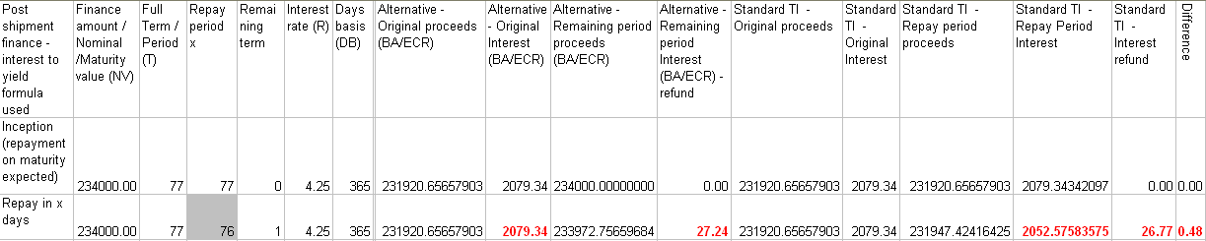

Early discharge processed 38 days prior to maturity: ‘Difference’ is ‘USD 9.28’

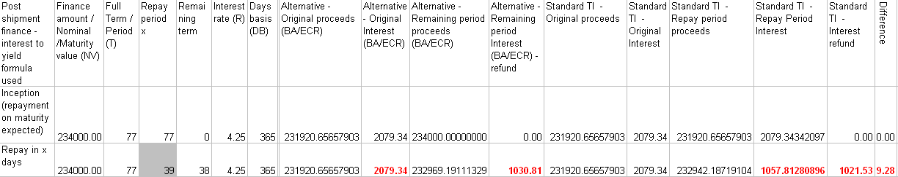

#### Using the Trade Innovation Standard Interest Formula:

Both methods deliver the same rebate result if the standard interest/discount formula is in use.

Standard interest/discount formula:

|  |  |
| --- | --- |
| Interest amount = | NV * R * T |
|  | Basis * 100 |

Where:

NV = Nominal or maturity value

R = Discount rate % per annum quoted to the customer

T = Days to maturity

Basis = interest days basis for the finance currency (in this example – 365 days)

Finance Amount = USD 234,000,

Tenor = 77days

Rate = 4.25%

Early discharge processed 1 day prior to maturity: ‘Difference’ is ‘0.00’

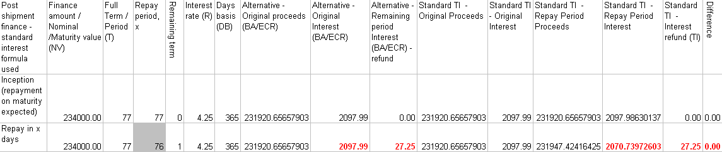

Early discharge processed 38 days prior to maturity: ‘Difference’ is ‘0.00’

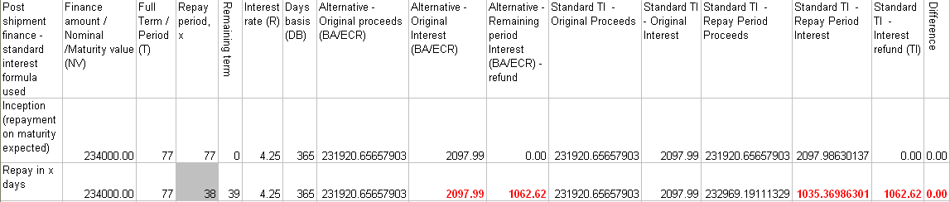

1. The major difference to the results occurs in the middle of the finance (to yield) period. For example, when 38 or 39 days remain. Using the Alternative method, the bank collects less interest and the customer benefits from the rebate.

### During Transaction Processing

The following sections show the results of applying the alternative interest formula during transaction processing.

#### Financing Transaction Repay Event with Early Repayment

Mark-up and cost of funds interest apply to this transaction. The alternative rebate calculation method applies to the interest overpaid amount and the ‘Rebate adjustment’ line is displayed. Cost of funds interest is shown separately for the payer and the funding party.

In the above example where a rebate is provided after one day, Mark-up interest is calculated as follows, using the alternative interest formula:

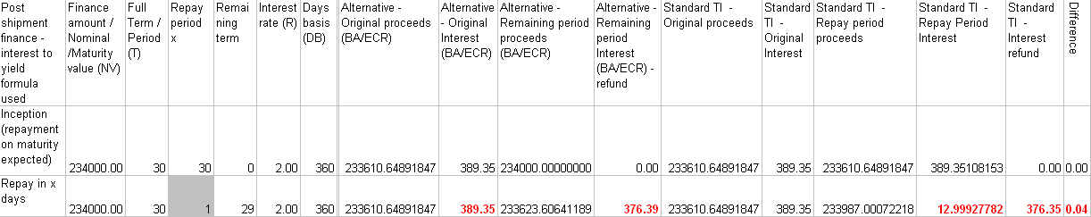

Finance amount 234,000.00000000

Alternative/Standard Original proceeds 233,610.64891847

Alternative/Standard Original interest 389.35

Alternative Remaining period interest 376.39

Standard TI Interest refund 376.35

Difference 0.04

Alternative remaining period proceeds 233,623.60641189

Standard TI Original proceeds 233,610.64891847

Alternative Repay period interest 12.95

Standard Repay period interest 12.99

Alternative Repay period interest 12.95

Difference 0.04

#### Financing Transaction Repay Event

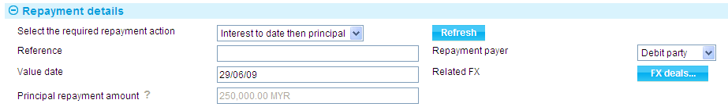

The Principal Repayment Amount’ field in the Repayment Details pane represents the amount of principal paid by the customer in this current Repay event. This field is not duplicated on the cost of funds side.



In the Cost of Funds (Payer) pane:

* The Interest Due to Date field shows cost of funds interest due from the customer which is accounted for in the main Repayment Details pane (if based on full customer interest rate). This field is display only
* The Interest Repayment Amount field shows the amount of cost of funds interest paid by the customer in the current Repay event. If interest repayment to the funding party occurs via batch, then this field is in display mode and its amount value is set to blank (that is, there is no repayment of interest through the current Repay event). Otherwise, this field takes its default value from the Interest Due to Date field. The default value can be overridden
* The Interest Overpaid Amount field shows a rebate to the customer from the funding party. This is calculated using either the standard or alternative interest rebate calculation method as applicable. In this situation, the Interest Due to Date would be blank

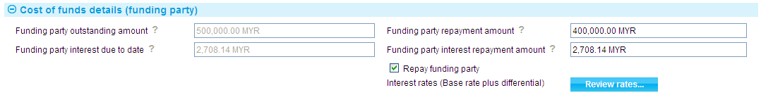

In the Cost of Funds (Funding Party) pane:

* The Funding Party Outstanding Amount field shows the principal amount yet to be paid, or returned to the funding party
* The Funding Party Repayment Amount field shows the amount of principal to be paid to the funding party through the current Repay event. This takes its default value from the Principal Repayment Amount field in the Repayment Details pane. The default value can be overridden. On completion of the Repay event, this amount reduces the funding party outstanding amount
* The Funding Party Interest Due to Date field shows cost of funds interest due to the funding party. This field is display only
* The Funding Party Interest Repayment Amount field shows the amount of cost of funds interest to be paid to the funding party in the current Repay event. If interest repayment to the funding party occurs via batch, this field is display only and the amount is set to blank (that is, there is no repayment of interest through the current Repay event). Otherwise, this field takes its default value from the Interest Repayment Amount field in the Cost of Funds (Payer) pane. This default value can be overridden

Depending on the repayment scenario, the following additional fields may be shown:

* The Funding Party Interest Overpaid Amount field shows a rebate from the funding party
* The Funding Party Underpaid Amount field is shown if the funding party repayment amount falls short of the funding party outstanding amount when the Repay event is being used to process a final payment
* The Funding Party Overpaid Amount field is shown if the funding party repayment amount exceeds the funding party outstanding amount when the Repay event is being used to process a final payment

The Repay Funding Party flag, illustrated below, is shown when interest payments to the funding party are set to occur via Repay events. This flag is also enabled when a principal payment is made through the current Repay event (that is, when either interest and/or principal are paid to the funding party).



# Example Postings

This chapter provides examples of each of the different kinds of posting that can be included in an event's posting set.

## Recording Liability

The following example shows a basic posting set for issuing a letter of credit for 100,000 USD to North Sea Oil on 2nd July 2012:

|  |  |  |  |  |  |  |  |  |  |
| --- | --- | --- | --- | --- | --- | --- | --- | --- | --- |
| DR/CR | Branch | Account | Value | Account Type | Amount | Type | Date | Liability | Track Residual |
| DR | Behalf of branch | Event party | Applicant | RA | Full available amount (including additional amount) | Total | Issue date | Y | Y |
| CR | Behalf of branch | System parameter SP501 | LC issuance liability | - | Full available amount (including additional amount) | Total | Issue date | N | N |

This will result in the following entries:

|  |  |  |  |  |  |
| --- | --- | --- | --- | --- | --- |
| DR/CR | Account | Short Name | Amount | Currency | Date |
| 1.DR | 1200-123456-690 | North Sea Oil | 100,000 | USD | 02JUL12 |
| 2. CR | 1200-897000-840 | @LI-USD | 100,000 | USD | 02JUL12 |

The first entry records customer liability against account type RA for the customer whilst the second entry is booked against the SP501 contra liability account.

## Recording Movement of Funds

When a payment is made under the import letter of credit, the issuing bank reduces the liability it originally recorded, debits the applicant's account with the amount due, and pays the advising bank.

For postings involving the payment or receipt of funds the account receiving or paying the funds is defined as a settlement account, as in the example below. When the postings are generated, the system retrieves the standing settlement instructions for the relevant event currency (see page 4).

|  |  |  |  |  |  |  |  |
| --- | --- | --- | --- | --- | --- | --- | --- |
| DR/CR | Branch | Account | Value | Account Type | Amount | Date | Transaction Code |
| CR | Behalf of branch | Event party | Applicant | RA | Payment amount | Payment value date | 791 - Letter of credit drawn |
| DR | Behalf of branch | System parameter | LC Issue contra | - | Payment amount | Payment value date | 291 - Letter of credit drawn |
| DR | Behalf of branch | Event party settlement | Applicant | Principal | Payment amount | Payment value date | 226 - LC payment |
| CR | Behalf of branch | Event party settlement | Advising bank | Principal | Payment amount | Payment value date | 651 - LC payment |

For a payment made on 27th July 2012 to the advising bank Boston Bank, the following entries would be generated:

|  |  |  |  |  |  |
| --- | --- | --- | --- | --- | --- |
| DR/CR | Account | Short Name | Amount | Currency | Date |
| 1. CR | 1200-123456-691 | NorthSeaOil | 50,000.00 | USD | 27JUL12 |
| 2. DR | 1200-897000-840 | @LI-USD | 50,000.00 | USD | 27JUL12 |
| 3. DR | 1200-123456-001 | NorthSeaOil | 50,000.00 | USD | 27JUL12 |
| 4. CR | 1200-800840-001 | FWSB | 50,000.00 | USD | 27JUL12 |

The accounts for the first and second postings are derived in the same way as for contingent liabilities, described in the previous section.

The retrieved standing settlement instructions allow the applicant's current account to be identified. In this case, the issuing bank has set up standing instructions for the applicant defining the account in their books to be debited whenever US Dollars are to be received from the customer.

The retrieved standing settlement instructions also define how the transaction is to be settled for the advising bank. In this case, the issuing bank has set up standing instructions which detail that, whenever US Dollars are to be paid to the advising bank they should credit their nostro First Wall Street Bank and send a payment advice instructing them to pay funds to the advising bank's account held at Main Street Bank.

## Payment in a Foreign Currency

The following example shows postings set up to handle payment in a currency different from that of the transaction for an import letter of credit:

|  |  |  |  |  |  |  |  |  |
| --- | --- | --- | --- | --- | --- | --- | --- | --- |
| DR/CR | Branch | Account | Value | | Account Type | Amount | Date | Transaction Code |
| CR | Behalf of branch | Event party | | Applicant | RA | Payment amount | Payment value date | 791 - Letter of credit drawn |
| DR | Behalf of branch | System parameter | | LC Issue contra | - | Payment amount | Payment value date | 291 - Letter of credit drawn |
| DR | Behalf of branch | Event party settlement | | Applicant | Principal | Source payment amount | Payment value date | 226 - LC payment |
| CR | Behalf of branch | System parameter SP503 | | TF exchange settlement | - | Source payment amount | Payment value date | From SP defined on Product options |
| DR | Behalf of branch | System parameter SP503 | | TF exchange settlement | - | Derived payment amount | Payment value date | From SP defined on Product options |
| CR | Behalf of branch | Event party settlement | | Advising bank | Principal | Derived payment amount | Payment value date | 651 - LC payment |

For a payment made on 27th July 2012 to the advising bank Boston Bank, the following entries would be generated:

|  |  |  |  |  |  |
| --- | --- | --- | --- | --- | --- |
| DR/CR | Account | Short Name | Amount | Currency | Date |
| 1. CR | 1200-123456-691 | NorthSeaOil | 50,000.00 | USD | 27JUL12 |
| 2. DR | 1200-897000-840 | @LI-USD | 50,000.00 | USD | 27JUL12 |
| 3. DR | 1200-123456-002 | NorthSeaOil | 35,714.28 | GBP | 27JUL12 |
| 4. CR | 1200-876108-826 | @LX-GBP | 35,714.28 | GBP | 27JUL12 |
| 5. DR | 1200-876108-840 | @LX-USD | 50,000.00 | USD | 27JUL12 |
| 6. CR | 1200-800840-001 | FWSB | 50,000.00 | USD | 27JUL12 |

The accounts for the first and second postings are derived in the same way as for contingent liabilities.

The retrieved standing settlement instructions allow the applicant's current account to be retrieved. In this case the issuing bank has set up standing settlement instructions for the applicant identifying the account in their books to be debited whenever Pounds Sterling are to be received from the applicant.

A credit is made to the TF Exchange Settlement account in Pounds Sterling and a debit to the TF Exchange Settlement account in US Dollars, to clear and reconcile the exchange settlement accounts maintained as the reconciliation point between the system and the back office.

The advising bank is then credited in the required currency.

1. If you do not set up any foreign exchange postings for an event, then the FX button in the Settlements window will not be available. This is to prevent imbalances in the exchange settlement accounts for the foreign exchange deal. See the Common Facilities User Guide – Trade Innovation for information on the Settlement Details window.

### Notifying Base Currency Equivalent to the Back Office

Some general ledgers may require the base currency equivalent for each leg of a cross currency FX deal to be posted.

This information can be set up in the posting narrative using the Parameter Set|Postings Narrative menu option in the System Tailoring application. See the System Tailoring User Guide – Trade Innovation for more details.

You can specify a label followed by the appropriate base currency equivalent field code.

For example to notify the base currency equivalent of the sale currency the following could be set up:

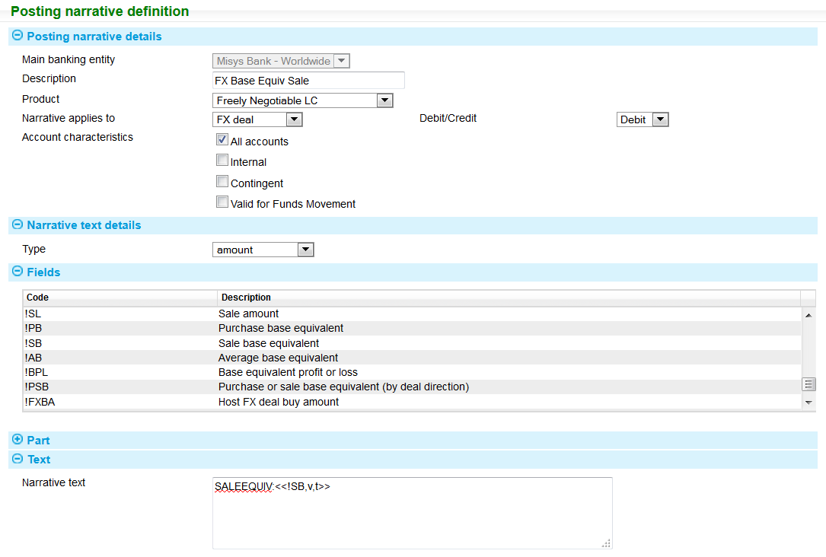

The receiving system can then identify the equivalent amount in the narrative from the label preceding the value.

## Discounting

The following example shows the postings set up to process a discounted payment for an export letter of credit:

|  |  |  |  |  |  |  |  |
| --- | --- | --- | --- | --- | --- | --- | --- |
| DR/CR | Branch | Account | Value | Account Type | Amount | Date | Transaction Code |
| DR | Behalf of branch | Event party settlement | Beneficiary | - | Payment amount | Acceptance maturity | 226 - LC payment |
| CR | Behalf of branch | System parameter | TF term settlement | - | Payment amount | Acceptance maturity | From SP |
| CR | Behalf of branch | Event party settlement | Beneficiary | Principal | Payment amount | Discount date | 651 - LC payment |
| DR | Behalf of branch | System parameter SP504 | TF term settlement | - | Payment amount | Discount date | From SP defined on Product options |
| DR | Behalf of branch | Event party settlement | Beneficiary | Interest | Discount amount | Discount date | 420 -Interest payment |
| CR | Behalf of branch | System parameter SP504 | TF term settlement | - | Discount amount | Discount date | From SP defined on Product options |

For a payment discounted from 27thAugust 2012 to 27thJuly 2012, the following entries would be generated:

|  |  |  |  |  |  |
| --- | --- | --- | --- | --- | --- |
| DR/CR | Account | Short Name | Amount | Currency | Date |
| 1. DR | 1200-800850-001 | FWSB | 50,000.00 | USD | 27AUG12 |
| 2. CR | 1200-876020-840 | @LT-USD | 50,000.00 | USD | 27AUG12 |
| 3. CR | 1200-800840-001 | FWSB | 50,000.00 | USD | 27JUL12 |
| 4. DR | 1200-876020-840 | @LT-USD | 50,000.00 | USD | 27JUL12 |
| 5. DR | 1200-800840-001 | FWSB | 166.67 | USD | 27JUL12 |
| 6. CR | 1200-876020-001 | @LT-USD | 166.67 | USD | 27JUL12 |

Entries 1 and 2 net with the original payment amount at maturity, resulting in no funds movement for the original acceptance date.

Entries 3 and 4 represent the payment of funds to the beneficiary on the discount date (entry 3), with a contra entry to SP504 TF Term Settlement account (entry 4) to reconcile the term settlement accounts maintained as the reconciliation point between the system and the back office.

Entries 5 and 6 represent the receipt of discount interest from the beneficiary for the discount start date (entry 5), with a contra entry to SP504 TF Term Settlement account (entry 6) to reconcile with the associated deal held in the back office system.

## Advance - Discount

The following example shows the postings set up to process an advance with interest at inception:

| DR/CR | Branch | Account | Value | Account Type | Amount | Date | Transaction Code |
| --- | --- | --- | --- | --- | --- | --- | --- |
| CR | Behalf of branch | Event party settlement | Drawer | Principal | Deal amount | Start date | 600 - loan start |
| DR | Behalf of branch | System parameter SP504 | TF term settlement | - | Deal amount | Start date | From SP |
| DR | Behalf of branch | Event party settlement | Discount payer | Interest | Discount amount | Start date | 420 - interest payment |
| CR | Behalf of branch | System parameter SP504 | TF term settlement | - | Discount amount | Start date | From SP |

A discounted advance from 27th August 2012 to 27thJuly 2012 would generate the following entries:

|  |  |  |  |  |  |
| --- | --- | --- | --- | --- | --- |
| DR/CR | Account | Short Name | Amount | Currency | Date |
| 1. CR | 1200-800840-001 | FWSB | 50,000.00 | USD | 27JUL12 |
| 2. DR | 1200-876020-840 | @LT-USD | 50,000.00 | USD | 27JUL12 |
| 3. DR | 1200-800840-001 | FWSB | 166.67 | USD | 27JUL12 |
| 4. CR | 1200-876020-840 | @LT-USD | 166.67 | USD | 27JUL12 |

Entries 1 and 3 represent the payment of funds to the drawer less discount payable at the deal start date.

Entries 2 and 4 represent the contra entries to SP504 to reconcile with the associated deal that will be generated in the back office system.

## Advance - Interest at Maturity

The following example shows the postings set up to process an advance with interest at maturity:

|  |  |  |  |  |  |  |  |
| --- | --- | --- | --- | --- | --- | --- | --- |
| DR/CR | Branch | Account | Value | Account Type | Amount | Date | Transaction Code |
| CR | Behalf of branch | Event party settlement | Drawer | Principal | Deal amount | Start date | 600 - loan start |
| DR | Behalf of branch | System parameter SP504 | TF term settlement | - | Deal amount | Start date | From SP |

The advance for a payment for period 27thJuly 2012 to 27th August 2012 would generate the following entries:

|  |  |  |  |  |  |
| --- | --- | --- | --- | --- | --- |
| DR/CR | Account | Short Name | Amount | Currency | Date |
| 1. CR | 1200-800840-001 | FWSB | 50,000.00 | USD | 27JUL12 |
| 2. DR | 1200-876020-840 | @LT-USD | 50,000.00 | USD | 27JUL12 |

Entry 1 represents the payment of funds to the drawer at the deal start date.

Entry 2 is the contra entry to SP504 to reconcile with the associated deal that will be generated in the back office system.

## Principal Repayment

The following example shows the posting set to process a repayment of principal against an advance:

|  |  |  |  |  |  |  |  |
| --- | --- | --- | --- | --- | --- | --- | --- |
| DR/CR | Branch | Account | Value | Account Type | Amount | Date | Transaction code |
| DR | Behalf of branch | Event party settlement | Send To party | Principal | Repayment amount | Repayment date | 130 - loan payment |
| CR | Behalf of branch | System parameter SP504 | TF term settlement | - | Repayment amount | Repayment date | From SP |

For a repayment of 20,000 USD for 27thAugust 2012, the following entries would be generated:

|  |  |  |  |  |  |
| --- | --- | --- | --- | --- | --- |
| DR/CR | Account | Short Name | Amount | Currency | Date |
| 1. DR | 1200-800840-001 | FWSB | 20,000.00 | USD | 27AUG12 |
| 2. CR | 1200-876020-840 | @LT-USD | 20,000.00 | USD | 27AUG12 |

For a repayment against a deal with interest at inception, entry 2 reconciles with the original deal created in the back office system when the advance was originally created.

For a repayment against a deal with interest at maturity, entry 1 represents the receipt of funds from the drawer, while entry 2 is a contra entry to SP504 to reconcile with the associated back office deal principal decrease that is generated at the same time as the entries.

## Interest Repayment

The following example shows the posting set to process a repayment of interest against an outstanding advance:

|  |  |  |  |  |  |  |  |  |
| --- | --- | --- | --- | --- | --- | --- | --- | --- |
| DR/CR | Branch | Account | Value | | Account Type | Amount | Date | Transaction code |
| DR | Behalf of branch | Event party settlement | | Send To party | Principal/ Interest | Interest amount | Repayment date | 420 - interest payment |
| CR | Behalf of branch | System parameter SP504 | | TF term settlement | - | Interest amount | Repayment date | From SP |

For an interest payment of 166.47 USD for 27thAugust 2012, the following entries would be generated:

|  |  |  |  |  |  |
| --- | --- | --- | --- | --- | --- |
| DR/CR | Account | Short Name | Amount | Currency | Date |
| 1. DR | 1200-800840-001 | FWSB | 166.47 | USD | 27AUG12 |
| 2. CR | 1200-876020-840 | @LT-USD | 166.47 | USD | 27AUG12 |

Entry 1 represents the receipt of the interest from the drawer, while entry 2 is a contra entry to SP504 to reconcile with the associated back office deal interest posting that is generated.

## Participating Bank Liability

The following examples show how postings can be set up in order to participate the liability for an export letter of credit and an accepted draft with other banks.

The examples use an export letter of credit issued by Chase NY, available by acceptance for 100,000 USD. The risk is shared 25% with one participant - the State Bank of Ohio. The examples show postings generated:

* When the letter of credit is advised
* When an amendment is received to confirm 100% of the LC.
* When an acceptance payment is then made of 20,000 USD.
* When the letter of credit is expired

### Advising the Unconfirmed Letter of Credit

The following example shows the posting set to advise the unconfirmed letter of credit for 100,000 USD:

|  |  |  |  |  |  |  |  |  |
| --- | --- | --- | --- | --- | --- | --- | --- | --- |
| DR/CR | Account | Value | Account Type | Amount | Type | Date | Liability | Track Residual |
| DR | Event party | Received from bank | RC | Confirmed amount | Total | Advice date | Y | Y |
| CR | System parameter SP502 | Confirmed LC liability | - | Confirmed amount | Less shared bank | Advice date | N | N |
| CR | Event party | Our bank share party | TS | Confirmed amount | Shared bank | Advice date | N | Y |

This will result in no postings as the letter of credit is currently unconfirmed. The master Summary window's liability panel will be blank.

### Amending the Letter of Credit

The following example shows the posting set for an amendment to confirm 100% of the letter of credit on the 27th July 2012. At this stage the bank decides to participate out 25% of its risk with the Bank of Ohio:

|  |  |  |  |  |  |  |  |  |
| --- | --- | --- | --- | --- | --- | --- | --- | --- |
| DR/CR | Account | Value | Account Type | Amount | Type | Date | Liability | Track Residual |
| DR | Event party | Received from bank | RC | Increase confirmed amount | Total | Amendment date | Y | Y |
| CR | System parameter SP502 | Confirmed LC liability | - | Increase confirmed amount | Less shared bank | Amendment date | N | N |
| CR | Event party | Our bank share party | TS | Increase confirmed amount | Shared bank | Amendment date | N | Y |

This will result in the following entries:

|  |  |  |  |  |  |
| --- | --- | --- | --- | --- | --- |
| DR/CR | Account | Short Name | Amount | Currency | Date |
| DR | 1200-123457-691 | Chase New York | 100,000 | USD | 27JUL12 |
| CR | 1200-897010-840 | @LF-USD | 75,000 | USD | 27JUL12 |
| CR | 1200-897654-691 | Bank of Ohio | 25,000 | USD | 27JUL12 |

The Master Summary window's liability panel will show the following values:

Total 100,000.00 USD (100,000.00 USD)

Participated 25,000.00 USD (25%)

The total liability figure is updated by postings where the Liability check box is set on. The figure in brackets represents the contingent liability. This is updated by postings where both the Liability check box and the Track Residual Liability check box are set on (see page 7). A credit posting subtracts from these figures, a debit posting adds to them.

The following details will be recorded against the sharing bank, the Bank of Ohio:

* Total liability 25,000
* Residual liability 25,000

The liability figure is the total amount for that party. The residual liability figure is updated only if the posting has the Track Residual Liability field checked. Where the liability is shared between banks the system displays the total amount of liability shared in the master Summary window, preceded by the label 'Shared', or 'Participated' if the transaction is participated. A credit posting adds to this figure, a debit posting subtracts from it.

### Documents Presented for an Acceptance Payment

The following example shows the posting set to process an acceptance payment of 20,000 USD on 2nd August 2012:

|  |  |  |  |  |  |  |  |  |
| --- | --- | --- | --- | --- | --- | --- | --- | --- |
| DR/CR | Account | Value | Account Type | Amount | Type | Date | Liability | Track Residual |
| CR | Event party | Received from bank | RC | Confirmed part pay amount | Total | Presentation date | Y | Y |
| DR | System parameter SP502 | Confirmed LC liability | - | Confirmed part pay amount | Less shared bank | Presentation date | N | N |
| DR | Event party | Our bank share party | TS | Confirmed part pay amount | Shared bank | Presentation date | N | Y |
| DR | Event party | Received from bank | RH | Part payment amount | Total | Start date of deferred period | Y | N |
| CR | System parameter SP505 | Acceptance liability | - | Part payment amount | Less shared bank | Start date of deferred period | N | N |
| CR | Event party | Our bank share party | TT | Part payment amount | Shared bank | Start date of deferred period | N | N |

The first three postings reverse out the contingent liability for the confirmed amount of the payment (20,000 USD).

The next three postings set up the acceptance liability for the accepted draft. These will be reversed on maturity of the acceptance payment. This will result in the following entries:

|  |  |  |  |  |  |
| --- | --- | --- | --- | --- | --- |
| DR/CR | Account | Short Name | Amount | Currency | Date |
| CR | 1200-123457-691 | Chase New York | 20,000 | USD | 02AUG12 |
| DR | 1200-897010-840 | @LF-USD | 15,000 | USD | 02AUG12 |
| DR | 1200-897654-691 | Bank of Ohio | 5,000 | USD | 02AUG12 |
| DR | 1200-123457-692 | Chase New York | 20,000 | USD | 02AUG12 |
| CR | 1200-897020-840 | @LC-USD | 15,000 | USD | 02AUG12 |
| CR | 1200-897654-692 | Bank of Ohio | 5,000 | USD | 02AUG12 |

The Master Summary window's liability panel will show the following values:

* Total 100,000.00 USD (80,000.00 USD)
* Participated 25,000.00 USD (25%)

The following details will be recorded against the participant, the Bank of Ohio:

* Total liability 25,000
* Residual liability 20,000

### Expiring the Letter of Credit

The following example shows the posting set to expire the letter of credit on 28th September 2012 to write off any outstanding contingent liability:

|  |  |  |  |  |  |  |  |  |
| --- | --- | --- | --- | --- | --- | --- | --- | --- |
| DR/CR | Account | Value | Account Type | Amount | Type | Date | Liability | Track Residual |
| CR | Event party | Received from bank | RC | Residual liability amount | Total | Expiry date | Y | Y |
| DR | System parameter SP502 | Confirmed LC liability | - | Residual liability amount | Less shared bank | Expiry date | N | N |
| DR | Event party | Our bank share party | TS | Residual liability amount | Shared bank | Expiry date | N | Y |

This will result in the following entries:

|  |  |  |  |  |  |
| --- | --- | --- | --- | --- | --- |
| DR/CR | Account | Short Name | Amount | Currency | Date |
| CR | 1200-123457-691 | Chase New York | 80,000 | USD | 28SEP12 |
| DR | 1200-897010-840 | @LF-USD | 60,000 | USD | 28SEP12 |
| DR | 1200-897654-691 | Bank of Ohio | 20,000 | USD | 28SEP12 |

The Master Summary window's liability panel will show the following values:

* Total 20,000.00 USD
* Participated 5,000.00 USD (25%)

The following details will be recorded against the participant, the Bank of Ohio:

* Total liability 5,000
* Residual liability 0

## Sharing Customer Liability

The following examples show how postings can be set up in order to share the liability for an import letter of credit and an accepted draft between customers. The examples use an import letter of credit issued for the applicant North Sea Oil, available by acceptance for 100,000 USD. Their risk is shared 25% with Global Oil Explorations Inc. The examples show postings generated:

* When the letter of credit is issued
* When an acceptance payment is then made of 20,000 USD
* When an amendment increases the value of the LC by 20,000 USD

### Issuing the Letter of Credit

The following example shows the posting set for issuing a letter of credit for 100,000 USD:

|  |  |  |  |  |  |  |  |  |
| --- | --- | --- | --- | --- | --- | --- | --- | --- |
| DR/CR | Account | Value | Account Type | Amount | Type | Date | Liability | Track Residual |
| DR | Event party | Applicant | RA | Full available amount (including additional amount) | Less shared customer | Issue date | Y | Y |
| DR | Event party | Customer share party | RA | Full available amount (including additional amount) | Shared customer | Issue date | Y | Y |
| CR | System parameter SP501 | LC issuance liability | - | Full available amount (including additional amount) | Total | Issue date | N | N |

This will result in the following entries:

|  |  |  |  |  |  |
| --- | --- | --- | --- | --- | --- |
| DR/CR | Account | Short Name | Amount | Currency | Date |
| DR | 1200-123456-690 | North Sea Oil | 75,000 | USD | 27JUL12 |
| DR | 1200-123458-690 | GlobalOilEx | 25,000 | USD | 27JUL12 |
| CR | 1200-897000-840 | @LI-USD | 100,000 | USD | 27JUL12 |

The Master Summary window's liability panel will show the following values:

* Total 100,000.00 USD (100,000.00 USD)

The following details will be recorded against the sharing customer, Global Oil Explorations:

* Total liability 25,000
* Residual liability 25,000

### Claim Received for an Acceptance Payment

The following example shows the posting set to process an acceptance payment of 20,000 USD on 2nd August 2012:

|  |  |  |  |  |  |  |  |  |
| --- | --- | --- | --- | --- | --- | --- | --- | --- |
| DR/CR | Account | Value | Account Type | Amount | Type | Date | Liability | Track Residual |
| CR | Event party | Applicant | RA | Part payment amount | Less shared customer | Presentation date | Y | Y |
| CR | Event party | Customer share party | RA | Part payment amount | Shared customer | Presentation date | Y | Y |
| DR | System parameter SP501 | LC issuance liability | - | Part payment amount | Total | Presentation date | N | N |
| DR | Event party | Received from bank | RH | Part payment amount | Less shared customer | Start date of deferred period | Y | N |
| DR | Event party | Customer share party | RH | Part payment amount | Shared customer | Start date of deferred period | N | N |
| CR | System parameter SP505 | Acceptance liability | - | Part payment amount | Total | Start date of deferred period | N | N |

The first three postings reverse out the contingent liability for the amount of the payment (20,000 USD).

The next three postings set up the acceptance liability for the accepted draft. These will be reversed on maturity of the acceptance payment.

This will result in the following entries:

|  |  |  |  |  |  |
| --- | --- | --- | --- | --- | --- |
| DR/CR | Account | Short Name | Amount | Currency | Date |
| CR | 1200-123456-690 | North Sea Oil | 15,000 | USD | 02AUG12 |
| CR | 1200-123458-690 | GlobalOilEx | 5,000 | USD | 02AUG12 |
| DR | 1200-897000-840 | @LI-USD | 20,000 | USD | 02AUG12 |
| DR | 1200-123456-692 | North Sea Oil | 15,000 | USD | 02AUG12 |
| DR | 1200-123458-692 | GlobalOilEx | 5,000 | USD | 02AUG12 |
| CR | 1200-897020-840 | @LC-USD | 20,000 | USD | 02AUG12 |

The Master Summary window's liability panel will show the following values:

* Total 100,000.00 USD (80,000.00 USD)

The following details will be recorded against the sharing customer, Global Oil Explorations:

* Total liability 25,000
* Residual liability 20,000

### Amending the Letter of Credit

The following example shows the posting set to increase the letter of credit by 20,000 USD on 14th August 2012:

|  |  |  |  |  |  |  |  |  |
| --- | --- | --- | --- | --- | --- | --- | --- | --- |
| DR/CR | Account | Value | Account Type | Amount | Type | Date | Liability | Track Residual |
| DR | Event party | Applicant | RA | Increase maximum liability | Less shared customer | Amendment date | Y | Y |
| DR | Event party | Customer share party | RA | Increase maximum liability | Shared customer | Amendment date | Y | Y |
| CR | System parameter SP501 | LC issuance liability | - | Increase maximum liability | Total | Amendment date | N | N |

This will result in the following entries:

|  |  |  |  |  |  |
| --- | --- | --- | --- | --- | --- |
| DR/CR | Account | Short Name | Amount | Currency | Date |
| DR | 1200-123456-690 | North Sea Oil | 15,000 | USD | 14AUG12 |
| DR | 1200-123458-690 | GlobalOilEx | 5,000 | USD | 14AUG12 |
| CR | 1200-897000-840 | @LI-USD | 20,000 | USD | 14AUG12 |

The Master Summary window's liability panel will show the following values:

* Total 120,000.00 USD (100,000.00 USD)

The following details will be recorded against the sharing customer, Global Oil Explorations:

* Total liability 30,000
* Residual liability 25,000

## Financing

By default, postings for daily interest accruals for financing transactions are made to accounts defined by SP parameters, and accruals and liability are not recorded at customer level.

The system allows your bank instead to record liability at customer level. This is done by using the branch system option CustIntAccrualAccType to select an account type. Once the system option has been set, postings are made to accounts of that type at individual customer level.

If your bank starts using this system option, it will need to set up the starting balances of the various customers manually. Also you will need to review the postings set up for products for which interest income accruals are generated, to ensure that the same account type is used in repayment postings as in the postings used to make accruals. This is to ensure that accruals are ‘unwound’ correctly during repayment events.

Your bank will need to make this sort of change for every product for which you generate interest income accruals. Typically, it will be necessary to change all the contra postings for products affected.

If your bank starts using this system option, it will need to set up the starting balances of the various customers manually. Also you will need to review the postings set up for products for which interest income accruals are generated, to ensure that the same account type is used in repayment postings as in the postings used to make accruals.

The following sections show example posting set up for an import standalone financing transaction to record the loan (asset) and the settlement of the loan proceeds:

### Creating the Financing Transaction

|  |  |  |  |  |  |  |  |  |
| --- | --- | --- | --- | --- | --- | --- | --- | --- |
| DR/CR | | Branch | Account | Value | Account Type | Amount | Date | Transaction Code |
| DR | Behalf of branch | | Event party | Debit party | L2 | Finance deal amount | Start date | 331 - BF create |
| CR | Behalf of branch | | Event party settlement | Finance to party | Principal | Finance deal amount | Start date | 510 – Credit |

For a standalone import financing provided to North Sea Oil for 1,000,000 USD on the 26th September 2012 for the payment of a draft to an overseas beneficiary, the following entries would be generated:

|  |  |  |  |  |  |
| --- | --- | --- | --- | --- | --- |
| DR/CR | Account | Short Name | Amount | Currency | Date |
| DR | 1200-123456-692 | NorthSeaOil | 1,000,000.00 | USD | 26SEP12 |
| CR | 1200-800840-001 | FWSB | 1,000,000.00 | USD | 26SEP12 |

The account for the first posting is derived by the system from the following:

* Branch mnemonic
* Customer mnemonic
* Currency
* Account type

The second posting relates to the settlement of the proceeds. The retrieved standing settlement instruction defines how the USD transaction is to be settled for third parties, in this case, whenever US Dollars are to be paid to a third party, they should credit the bank's nostro First Wall Street Bank and send a payment advice instructing them to pay funds to the third party's account (details as input with the transaction).

### Interest in Advance

When interest is taken in advance, the system generates the following postings:

|  |  |  |  |  |
| --- | --- | --- | --- | --- |
| DR/CR | Account | Amount | Date | Currency |
| DR | Customer | Projected interest amount | Repayment Date | Interest currency |
| CR | SP628 | Interest unearned amount | Repayment Date | Interest currency |

The following postings are generated on a daily basis up to due date:

|  |  |  |  |  |
| --- | --- | --- | --- | --- |
| DR/CR | Account | Amount | Date | Currency |
| DR | SP628 | Daily interest accrual | Daily | Interest currency |
| CR | SP626 | Daily interest accrual | Daily | Interest currency |

If the system option CustIntAccrualAccType has been set the SP used for unearned interest (SP628) is replaced with the account type set up for the system option (BF):

|  |  |  |  |  |
| --- | --- | --- | --- | --- |
| DR/CR | Account | Amount | Date | Currency |
| DR | Customer | Projected interest amount | Repayment Date | Interest currency |
| CR | BF | Interest unearned amount | Repayment Date | Interest currency |

The following postings are generated on a daily basis up to interest maturity date:

|  |  |  |  |  |
| --- | --- | --- | --- | --- |
| DR/CR | Account | Amount | Date | Currency |
| DR | BF | Daily interest accrual | Daily | Interest currency |
| CR | SP626 | Daily interest accrual | Daily | Interest currency |

### Interest in Arrears

When interest is taken in arrears, the system generates the following postings on a daily basis up to the interest maturity date:

|  |  |  |  |  |
| --- | --- | --- | --- | --- |
| DR/CR | Account | Amount | Date | Currency |
| DR | SP627 | Daily interest accrual | Daily | Interest currency |
| CR | SP626 | Daily interest accrual | Daily | Interest currency |

At maturity date, the following entry is posted:

|  |  |  |  |  |
| --- | --- | --- | --- | --- |
| DR/CR | Account | Amount | Date | Currency |
| DR | Customer | Total accrued interest amount | Repayment Date | Interest currency |
| CR | SP627 | Interest repaid amount | Repayment Date | Interest currency |

If the system option CustIntAccrualAccType has been set the SP used for interest receivable (SP627) is replaced with the account type set up for the system option (BF):

|  |  |  |  |  |
| --- | --- | --- | --- | --- |
| DR/CR | Account | Amount | Date | Currency |
| DR | BF | Daily interest accrual | Daily | Interest currency |
| CR | SP626 | Daily interest accrual | Daily | Interest currency |

At maturity date, the following posting is made:

|  |  |  |  |  |
| --- | --- | --- | --- | --- |
| DR/CR | Account | Amount | Date | Currency |
| DR | Customer | Total accrued interest amount | Repayment Date | Interest currency |
| CR | BF | Interest repaid amount | Repayment Date | Interest currency |

### Interest Accrual/Amortisation

Account posting for accrual/amortisation is generated on a daily basis up to the interest accrual date:

|  |  |  |  |  |  |  |
| --- | --- | --- | --- | --- | --- | --- |
| DR/CR | Branch | Account | Value | Amount | Date | Transaction code |
| CR | Behalf of branch | System parameter | Interest P/L Behalf Of Branch | Interest Behalf Of Branch | Accrual date | 510 – Credit |
| CR | Input branch | System parameter | Interest P/L Input Branch | Interest Behalf Of Branch | Accrual date | 510 – Credit |
| DR | Behalf of branch | System parameter | Interest Contra Behalf Of Branch | Interest Behalf Of Branch | Accrual date | 010 – Debit |
| DR | Input branch | System parameter | Interest Contra Input Branch | Interest Behalf Of Branch | Accrual date | 010 – Debit |

The following table shows account posting generated at the end of each day, for a USD loan with 100 USD daily interests, assuming 100% of interest is to be booked against the behalf of branch:

|  |  |  |  |  |  |
| --- | --- | --- | --- | --- | --- |
| DR/CR | Account | Short Name | Amount | Currency | Date |
| CR | 1200-951101-840 | Interest P/L | 100.00 | USD | 26SEP12 |
| DR  or | 1200-971101-840 | Advance interest | 100.00 | USD | 26SEP12 |
| DR | 1200-981101-840 | Interest receivable | 100.00 | USD | 26SEP12 |

1. These postings are derived automatically from the interest accounting set up. You do not need to set up in the posting set up function.

The account for the first posting is derived by the system fromSP626 - Interest income.

The second posting only applies if the transaction is an interest in advance financing. The account for the second posting is derived by the system fromSP628 - Advance interest received.

The third posting only applies if the transaction is an interest in arrears financing. The account for the third posting is derived by the system fromSP627 - Interest receivable.

### Finance Repayment - Principal

The following example shows the posting set required to process the repayment of principal against an advance:

|  |  |  |  |  |  |  |  |
| --- | --- | --- | --- | --- | --- | --- | --- |
| Dr/Cr | Branch | Account | Value | Account Type | Amount | Date | Transaction Code |
| CR | Behalf of branch | Event party | Debit party | L2 | Principal repaid amount | Repay date | 846 - BF repayment |
| DR | Behalf of branch | Event party settlement | Repayment party | Principal | Principal repaid amount | Repay date | 010 - Debit |

For a repayment of the import financing created in the earlier example (see page 64) to North Sea Oil the following postings would be generated:

|  |  |  |  |  |  |
| --- | --- | --- | --- | --- | --- |
| Dr/Cr | Account | Short Name | Amount | Currency | Date |
| 1. CR | 1200-123456-692 | NorthSeaOil | 1,000,000.00 | USD | 26OCT12 |
| 2. DR | 1200-123456-001 | NorthSeaOil | 1,000,000.00 | USD | 26OCT12 |

The first posting reverses the loan entry generated when the loan was created.

The second posting relates to the settlement of the proceeds. The retrieved standing settlement instruction defines how the USD transaction is to be settled for North Sea Oil's, in this case, the North Sea Oil USD current account with the bank.

If the repayment is the final repayment, under- or over-payment of principal may occur, that is, the total amount received is less or more that the total amount required to retire the loan. Additional posting will be required.

#### Underpayment of Principal

The following table shows the postings generated by an under-payment of principal:

|  |  |  |  |  |  |  |  |
| --- | --- | --- | --- | --- | --- | --- | --- |
| Dr/Cr | Branch | Account | Value | Account Type | Amount | Date | Transaction Code |
| CR | Behalf of branch | Event party | Debit party | L2 | Under payment | Repay date | 846 - BF repayment |
| DR | Behalf of branch | Event party settlement | Finance to party | Principal | Under payment | Repay date | 010 – Debit |

For a repayment of the import financing created in the earlier example (see page 64) to North Sea Oil with 100,000 USD under payment the following postings would be generated:

|  |  |  |  |  |  |
| --- | --- | --- | --- | --- | --- |
| Dr/Cr | Account | Short name | Amount | Currency | Date |
| CR | 1200-123456-692 | NorthSeaOil | 100,000.00 | USD | 25OCT12 |
| DR | 1200-123456-001 | NorthSeaOil | 100,000.00 | USD | 25OCT12 |

#### Overpayment of Principal

If the total received amount from the third party is in excess of the amount needed to retire the loan, the postings shown in the following table are generated:

|  |  |  |  |  |  |  |  |
| --- | --- | --- | --- | --- | --- | --- | --- |
| Dr/Cr | Branch | Account | Value | Account Type | Amount | Date | Transaction Code |
| CR | Behalf of branch | Event party | Debit party | L2 | Principal outstanding | Repay date | 846 - BF repayment |
| DR | Behalf of branch | Event party settlement | Debit party | Principal | Total amount received | Repay date | 010 – Debit |
| CR | Behalf of branch | Event party settlement | Finance to party | Principal | Overpaid principal amount | Repay date | 510 – Credit |

For a repayment of the same import loan, with 100,000 USD overpayment of principal the following postings are generated:

|  |  |  |  |  |  |
| --- | --- | --- | --- | --- | --- |
| Dr/Cr | Account | Short Name | Amount | Currency | Date |
| CR | 1200-123456-692 | NorthSeaOil | 1,000,000.00 | USD | 25OCT12 |
| DR | 1200-800840-001 | FWSB | 1,100000.00 | USD | 25OCT12 |
| CR | 1200-123456-001 | NorthSeaOil | 100,000.00 | USD | 25OCT12 |

The first posting reverses the loan entry generated when the loan was created with the principal outstanding amount.

The second relates to the receipt of funds from overseas bank. The retrieved standing settlement instruction defines how the USD transaction is to be settled for third parties, in this case, whenever US Dollars are to be paid to a third party, they should debit the bank's nostro First Wall Street Bank and send a payment advice instructing them to pay funds to the third party's account (details as input with the transaction).

The third relates to the settlement of the excess amount received to be paid over North Sea Oil, the original finance to party. The retrieved standing settlement instruction defines how the USD transaction is to be settled for North Sea Oil, in this case, the North Sea Oil USD current account with the bank.

#### Overpayment of Interest

For interest in advance transactions (NOT discount or discount to yield), if an early repayment has been received (that is, the repayment date is earlier than the due date of the loan), the system will calculate the amount of interest overpaid, and allows the bank either to keep or refund the excess interest charged. The accounting entries generated are as follows:

|  |  |  |  |  |  |  |  |
| --- | --- | --- | --- | --- | --- | --- | --- |
| Dr/Cr | Branch | Account | Value | Account Type | Amount | Date | Transaction Code |
| DR | Behalf of branch | System account | Finance - Contra BOB | Interest - Behalf Of Branch | Overpaid interest  Behalf Of Branch | Repay date | 010 – Debit |
| DR | Input branch | System account | Finance - Contra INP | Interest - Input branch | Overpaid interest  Input Branch | Repay date | 010 – Debit |
| CR | Behalf of branch | Event party settlement | Discount payer | Interest | Overpaid Interest amount | Repay date | 510 – Credit |

For an early repayment of the import financing created to North Sea Oil in the earlier example, with 3 days interest overpaid refunded, assuming interest booking is to behalf of branch only, the following postings would be generated:

|  |  |  |  |  |  |
| --- | --- | --- | --- | --- | --- |
| Dr/Cr | Account | Short name | Amount | Currency | Date |
| 1. DR | 1200-971101-840 | Adv. Int. received | 300.00 | USD | 23OCT12 |
| 2. CR | 1200-123456-001 | NorthSeaOil | 300.00 | USD | 23OCT12 |

The first posting reverses the overpaid interest from the unearned account booked at the start of the loan. The second posting is the settlement account for North Sea Oil.

#### Overpaid Interest Not Refunded (Waived)

If the bank decided to keep the overpaid interest, the overpaid amount can be booked to income immediately, that is directly into the P/L accounts, therefore no further amortisation is required the following table shows the postings used:

|  |  |  |  |  |  |  |  |
| --- | --- | --- | --- | --- | --- | --- | --- |
| Dr/Cr | Branch | Account | Value | Account Type | Amount | Date | Transaction Code |
| CR | Behalf of branch | System parameter | Interest P/L Behalf Of Branch |  | Overpaid Interest Behalf Of Branch | Repay date | 510 – Credit |
| CR | Input branch | System parameter | Interest P/L Input Branch |  | Overpaid Interest Behalf Of Branch | Repay date | 510 – Credit |
| DR | Behalf of branch | System parameter | Interest Contra Behalf Of Branch |  | Overpaid Interest Behalf Of Branch | Repay date | 010 – Debit |
| DR | Input branch | System parameter | Interest Contra Input Branch |  | Overpaid Interest Behalf Of Branch | Repay date | 010 – Debit |

For the same example above, the Credit posting is posted to the interest P/L instead of the North Sea Oil settlement account:

|  |  |  |  |  |  |
| --- | --- | --- | --- | --- | --- |
| Dr/Cr | Account | Short Name | Amount | Currency | Date |
| 1. CR | 1200-951101-840 | Interest P/L | 300.00 | USD | 23OCT12 |
| 2. DR | 1200-971101-840 | Advance interest | 300.00 | USD | 23OCT12 |

### Repayment of Interest

For interest in arrears transactions, interest can be repaid either at the due date of the loan together with the outstanding principal, or periodically if required:

|  |  |  |  |  |  |  |  |
| --- | --- | --- | --- | --- | --- | --- | --- |
| Dr/Cr | Branch | Account | Value | Account Type | Amount | Date | Transaction Code |
| CR | Behalf of branch | System account | Finance - Contra BOB | Interest - Behalf Of Branch | Interest  Behalf Of Branch | Start date | 510 – Credit |
| CR | Input branch | System account | Finance - Contra INP | Interest - Input branch | Interest  Input Branch | Start date | 510 – Credit |
| DR | Behalf of branch | Event party settlement | Discount payer | Interest | Interest amount | Start date | 010 – Debit |

For the same loan as above the 27 days interest received from North Sea Oil, assuming 100% of interest to be booked against behalf of branch, the following postings are generated:

|  |  |  |  |  |  |
| --- | --- | --- | --- | --- | --- |
| Dr/Cr | Account | Short name | Amount | Currency | Date |
| CR | 1200-981101-840 | Interest receivable | 2,700.00 | USD | 23OCT12 |
| DR | 1200-123456-001 | FWSB | 2,700.00 | USD | 23OCT12 |

The account for the first posting is derived by the system from the SP627 -Interest receivable

The second posting relates to the settlement of the proceeds. The retrieved standing settlement instruction defines how the USD transaction is to be settled for third parties, in this case, whenever US Dollars are to be paid to a third party, they should credit the bank's nostro First Wall Street Bank and send a payment advice instructing them to pay funds to the third party's account (details as input with the transaction).

### Past Due Transfer Finance

The accounting requirements for past due loans varies from country to country and from bank to bank. Some countries, as a central bank statutory reporting requirement, report all past due loans separately from other loans within the Balance Sheet. The system provides an optional facility for this transfer to be carried out automatically, on the close of business of the due date, or on a grace period after the due date. If the transfer is to happen on due date, then the posting set is to be set up as part of the past due event. If the transfer is to happen on a number of days (grace period), then the posting set is to be set up against the Past due transfer finance event.

|  |  |  |  |  |  |  |  |
| --- | --- | --- | --- | --- | --- | --- | --- |
| Dr/Cr | Branch | Account | Value | Account Type | Amount | Date | Transaction Code |
| CR | Behalf of branch | Event party | Debit party | L2 | Outstanding amount | Transfer date | 510 – Credit |
| DR | Behalf of branch | Event party | Debit party | L9 | Outstanding amount | Transfer date | 010 – Debit |

For a standalone export financing provided to North Sea Oil for 1,000,000 USD on the 26th September 2012 for the payment of a draft to an overseas beneficiary, which was due on 26th October 2012. On the due date, no repayment arrived. The outstanding amount of 1,000,000 USD is to be transferred to another account within the general ledger.

|  |  |  |  |  |  |
| --- | --- | --- | --- | --- | --- |
| Dr/Cr | Account | Short Name | Amount | Currency | Date |
| CR | 1200-123456-692 | NorthSeaOil | 1,000,000.00 | USD | 26OCT12 |
| DR | 1200-123456-693 | NorthSeaOil | 1,000,000.00 | USD | 26OCT12 |

The first posting reverses the original posting generated. The account for the second posting is derived by the system for the relevant branch, customer, currency and account type for the transfer.

## Financing - Liability Reversal Postings

The following examples show posting set up for an import standalone financing transaction to record the loan (asset) and the settlement of the loan proceeds.

The system provides a facility that allows for adjustment of liability postings recorded for a transaction. This facility is designed to be used on participated transactions and enables the liability to be altered to reflect the split of liability between the main bank and participants when details of the participants are changed.

A new category of posting is used to alter the liability - the reversal.

1. While the system permits you to set up reversals for any event, they are supported only for Maintain Liability events. If you wish to use it for other purposes then you must consider the postings that you need to set up very carefully.

The following example shows how reversals are used on a participated export letter of credit.

An export letter of credit issued by Chase NY is 100% confirmed on an amount of 100,000 USD. An acceptance payment for 20,000 USD has already been presented but not yet paid. Later it is decided to participate with another bank (Bank B) at 25% using the Maintain Liability event to establish the participation.

The following postings are defined for the event in order to reverse out the confirmed and acceptance risk and then re-apportion 25% of this risk to Bank B:

|  |  |  |  |  |  |  |
| --- | --- | --- | --- | --- | --- | --- |
| Dr/Cr | Account | Value | Type | Liability | Track Residual | Account type |
| - | System parameter SP502 | - | Reversal | N | N |  |
| - | Bank share party | - | Reversal | N | N | TS - shared liability |
| - | System parameter SP505 | - | Reversal | N | N |  |
| - | Bank share party | - | Reversal | N | N | TT - shared acceptance liability |
| Cr | System parameter SP502 | Residual liability amount | Less shared bank | N | Y |  |
| Cr | Bank share party | Residual liability amount | Shared bank | N | Y | TS |
| Cr | System parameter SP505 | Outstanding acceptance amount | Less shared bank | N | N |  |
| Cr | Bank share party | Outstanding acceptance amount | Shared bank | N | N | TT |

The system uses the reversal postings to identify all previous postings made in the following way:

* For a reversal of postings to a system parameter account it nets together all previous postings made on the transaction that have that system parameter defined. If this gives a credit balance then a debit posting is created to clear it and vice versa
* For a reversal of postings to a party account it nets together all previous postings made on the transaction that have that party and account type defined. If this gives a credit balance then a debit posting is created to clear it and vice versa. Where the party is 'Bank share party' then the system nets for each party which has been set as a bank sharing party (including participants)

This will result in the following entries:

|  |  |  |
| --- | --- | --- |
| Dr/Cr | Party | Amount |
|  |  | REVERSALS |
| Dr | SP502 | 80,000 |
| Dr | SP505 | 20,000 |
|  |  | NEW FIGURES |
| Cr | SP502 | 60,000 |
| Cr | SP505 | 15,000 |
| Cr | Bank B - TS | 20,000 |
| Cr | Bank B - TT | 5,000 |

The Master Summary window's liability panel will show the following values:

|  |  |  |  |
| --- | --- | --- | --- |
| Total | 100,000.00 USD (80,000.00 USD) | Participated | 25% (25,000.00 USD) |

The following details will be recorded against participant Bank B:

* Total liability 25,000
* Residual liability 20,000

# Legacy System Transaction Take-on

This chapter provides information relating to the take-on of transactions from a legacy system.

## Incorporating Legacy System Transactions

Your bank can incorporate transactions into the system from a legacy system using customer gateway interface service messages. Currently this functionality is reserved for use with:

* Export guarantees
* Export letters of credit
* Import guarantees
* Import letters of credit

Each transaction is received as a customer gateway interface service message, which is processed in the usual way. Each such message, once successfully processed, is used to create a data take-on event (an Advise Take-on event for export letters of credit and guarantees, and an Issue Take-on event for import letters of credit and guarantees) and associated master record in the system. The data take-on event is automatically released, and the master record given a status of 'LIV' or 'EXP', depending on its expiry date. Processing can then be carried out against the master record in the usual way, using the standard guarantee or letter of credit events.

The transaction's original unique reference is recorded against the master record, together with the unique transaction reference generated within the system. The system allows you to set up a different product prefix, to be used instead of the standard product prefix, for use in generating transaction references for imported legacy transactions.

To allow legacy transactions to be incorporated into the workflow in this way, the system expects the required static, security and system tailoring data to have been set up within the system to support the events created. This includes, for example:

* Postings to handle current outstanding liability and residual margin
* Master-level tracer types and their schedules
* Charge types and their default schedules
* Note types

1. If any critical data is missing or in error (for example, a duplicate master record reference is provided, or a default periodic charge schedule is missing), the message fails to create a master record and is held in the customer gateway interface service queue for manually processing.

The system allows you to enter legacy transactions manually, using the standard Issue and Advise events. An additional field is provided to allow you to enter the transaction's unique reference from the legacy system.

The remainder of this chapter provides more detailed information on how postings and charges are handled.

## Postings

Your bank will need to set up postings for data take-on events to allow the calculation of master-level liability and margin amounts at master level within the system.

If your bank uses the departmental limits application, liability postings for data take-on events will need to be configured to update current limit availability within that application.

See the System Tailoring User Guide – Trade Innovation for instructions on setting up postings.

## Charges

The necessary charge types and their default schedules must be predefined in the system for data take-on events. When the system releases a data take-on event it uses the information in the event and the charge types and schedules mapped to the event to generate the necessary charges.

Non-periodic charges are generated with a payment action of 'Defer'.

Periodic charges are generated with a payment action of 'Waive' or 'Take' (this is specified in the customer gateway interface service message). Charges with a status of 'Waive' will be changed automatically to a status of 'Take' at the start of the next cycle.

Charges statuses can be overridden in the usual way.

### Periodic Charge Accruals

The system supports two methods of handling periodic charge accruals for legacy transactions after they are incorporated into the system.

The first involves starting accruals immediately, during the first overnight processing run after the data take-on event is released. This makes it possible to incorporate a charge with either status - 'Take' or 'Waive'.

The second involves setting the status of the charge to 'Waive', then starting accruals from the beginning of the next charge cycle.

Any increases to the amount of the transaction between the release of the data take-on event and the start of the next charge cycle can be handled using another periodic charge based on the increase amount for the period up to the start of the original periodic charge's next cycle.

# Single-cycle Charges

Single-cycle periodic charges are designed to cover the duration of the transaction, using a single period, without predefined repeating charge periods and related regular charge payment events. For letters of credit, standby letters of credit, guarantees and participated deals, the system permits you to set up single-cycle charges - charges that are accrued over the period corresponding to the duration of the transaction, but taken in arrears when a payment is made. This caters for transactions involving large amounts and a lengthy life-cycle, typically, used to handle confirmation-type charge structures, where the charge basis amounts are sufficiently large that taking a confirmation charge in advance is not practical. For an example, a single-cycle charge is calculated from the day the transaction was confirmed (or silently confirmed) to the date of documents being settled, taking into account any decreases and or increases that took place during the period.

During payment events the input clerk can amend the amount of the charge. This does not affect the underlying charge running on the transaction including its accrual details.

For charges of this sort, your bank can choose whether accrual postings are generated or not.

Single-cycle charges are collected during payment events, at the same time as payment settles. They stop accruing when the final part-payment settles. They can be cancelled, if required, using a Maintain Charges event.

See the Common Facilities User Guide – Trade Innovation for charge calculation worked examples.

## Setting Up Single-cycle Schedules

Schedules for single-cycle charges are set up using the system tailoring application's Parameter set|Charge Types menu option.

The charge schedule is defined as being 'Periodic in arrears', and the Single Cycle Charge field checked to suppress normal periodic charge processing (namely, the generation of regular Pay Charges events to take charges) and to turn on single cycle periodic charge processing.

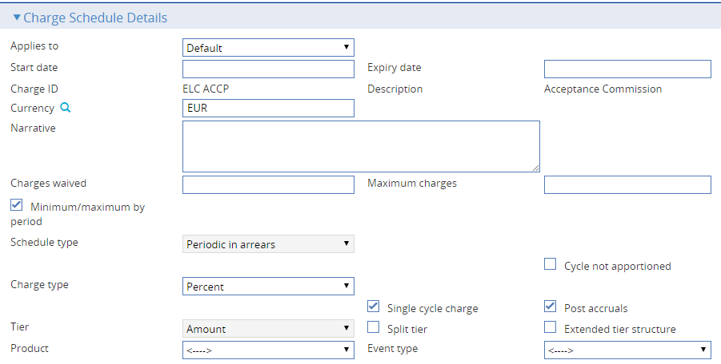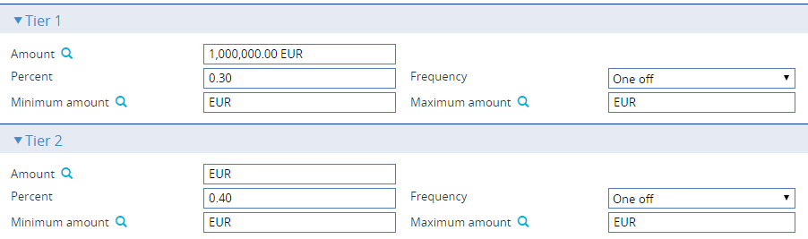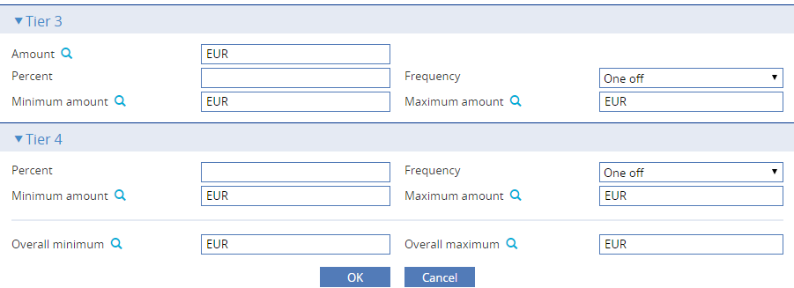

The schedule is then set up as for a normal periodic charge.

The Post Accruals flag controls whether accrual postings are to be generated for charges using this schedule or not. If checked, accruals are posted.

1. The system does not support any overall minimum/maximum amounts defined on the periodic charge schedule including single cycle charge.

## During Transaction Processing

During transaction processing, payment events for letters of credit, standby letters of credit and guarantees (that is, Claim Received, Outstanding Claim, Documents Presented and Outstanding Presentation events) have additional processing features to automatically calculate single cycle charges available for collection and to allow the input clerk to edit their details, if necessary.

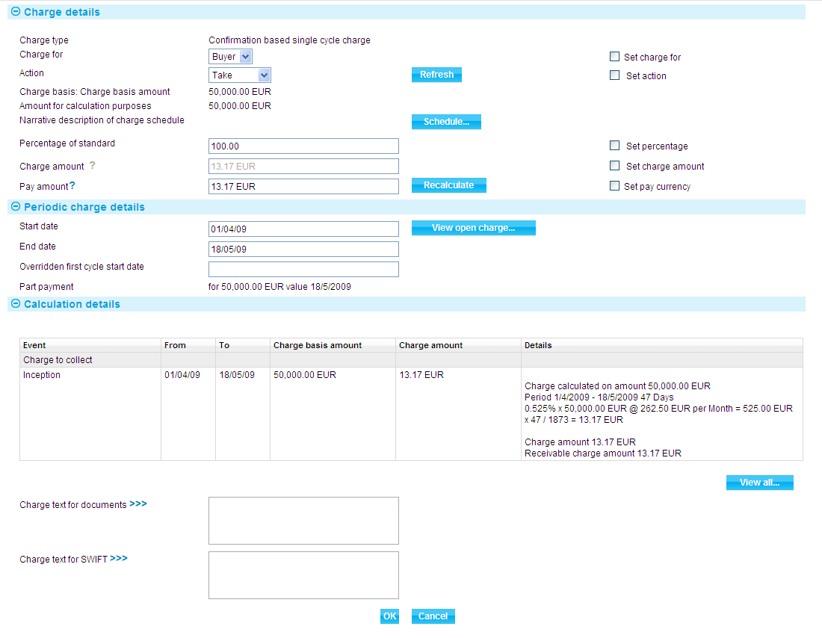

The View Open Charges button displays details of the charge calculations.

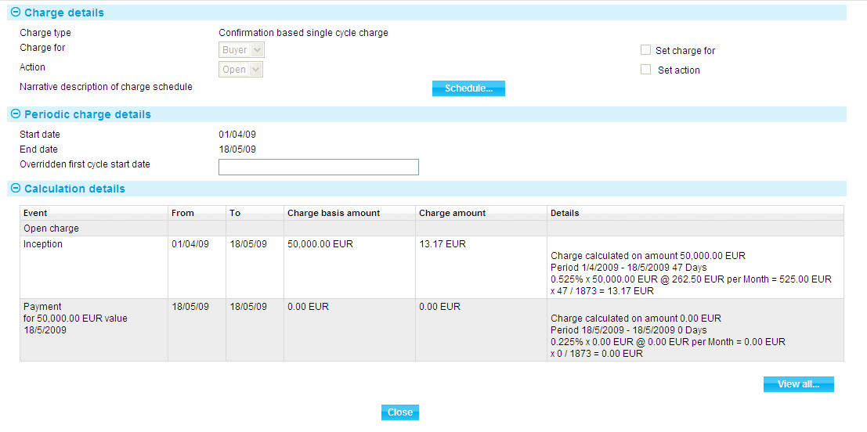

If a payment is rejected for any reason then no charge is taken. The underlying charge continues to accrue to the end date.

After the final payment the system stops collecting the charge; no further elements of the charge are collected for the remaining balance between final payment value date and the charge end date (for example, expiry).

### Amendments to the Master Record

Any amendment to the master record (resulting, for example, from a manual Amendment event, or by automatic increases or reductions) may cause a change to the charge basis amount or to the start or end date of a single-cycle periodic charge. In such a case the open charge is recalculated.

During an event the causes such an amendment, the charge schedule cannot be amended, and any standard periodic charge already in progress cannot be converted to single-cycle periodic charges.